Measles communications toolkit

Introduction

The number of people catching measles is rising in Greater Manchester. Measles is a very infectious disease - just a cough or sneeze can spread the virus to other people. It spreads easily and quickly among those who are not vaccinated, especially in nurseries and schools.
Measles can be very dangerous. One in five people with measles will go to hospital and in very rare cases people can die from the disease.
People in certain at-risk groups including babies and young children, pregnant women, and people with weakened immunity, are at increased risk of complications from measles.

We need to inform the people of Greater Manchester that measles cases are on the rise, the signs and symptoms of measles and also what the best protection against measles is (the measles, rubella and varicella vaccination)

Primary audiences
- Parents / guardians and carers of children aged 6-11 years (will be contacted about vaccinations)
- Parents / guardians and carers of children aged 1-5 years (will be contacted about vaccinations)
- GPs and other primary care
- Healthcare staff who aren’t vaccinated

Secondary audiences
- Parents / carers of children aged 12+
- Young adults from 17-25 years
- Those looking to conceive (MMRV vaccs before getting pregnant)
- Healthcare professionals
- Early years
- Education/teachers
- VCSFE sector
We need our information to address the following barriers

- Some people are less familiar with the diseases that the MMR and MMRV vaccine protects against, having never heard of or known of someone contracting them and therefore feels less relevant/important
- Some are concerned about the MMR and MMRV vaccine as they are deterred by the links to autism and ADHD and have heard that these side effects are especially more likely with boys.
- Some rejection of 3-in-1 vaccinations, especially from Jewish and Eastern European backgrounds, as they are considered to be more risky and harmful with fear of viral overload (i.e. the child has to fight 3 diseases at the same time instead of just one). Some in the Jewish community would like for these to be split out to reduce this perceived risk

The measles campaign will be added to as the situation becomes clearer for Greater Manchester and will include

- newsletter copy
- social media assets
- videos in community languages from trusted voices
- translated materials for WhatsApp
- Information for health care professionals leaflet with photos
- Information for early years settings leaflet with photos
- Easy read information for the Greater Manchester public
All of the assets will be available to download on the NHS Greater Manchester campaigns page.

We have also updated the measles page on our website with key information about measles, signs and symptoms and the MMRV vaccination. www.gmintegratedcare.org.uk/measles

How you can get involved
- The quickest and easiest way to support the campaign is to look out for the measles campaign on our social media channels and share to your followers. Please note our new GM ICP Facebook page - https://www.facebook.com/GreaterManchesterICP/
- Use the social media assets to schedule posts on your channels
- Promote the campaign using the suggested copy for newsletters
- Share this toolkit with partner organisations and stakeholder lists
- Share the WhatsApp messages in community WhatsApp groups

Please contact the NHS GM campaigns team if you have any questions or think there is something missing from this campaign that we can support with – gmhscp.gm-campaigns@nhs.net.

Newsletter copy

The number of people catching measles is rising in Greater Manchester

Measles is a very infectious disease - just a cough or sneeze can spread the virus to other people. It spreads easily and quickly among those who are not vaccinated, especially in nurseries and schools.
Measles can be very dangerous. One in five people with measles will go to hospital and in very rare cases people can die from the disease.
People in certain at-risk groups including babies and young children, pregnant women, and people with weakened immunity, are at increased risk of complications from measles.

If you think you or your child may have measles, stay at home and phone your GP or NHS 111 for advice. Stay away from GP surgeries, A&E departments and other health care venues. People with measles should stay off nursery, school, or work for at least 4 days from when the rash first appears.

Signs and symptoms
Measles usually starts with cold-like symptoms, followed by a rash a few days later. Some people may also get small spots in their mouth.

The first symptoms of measles include a high temperature, a runny or blocked nose, sneezing, a cough and red, sore, watery eyes. Small white spots may appear inside the cheeks and on the back of the lips a few days later. These spots usually last a few days. A rash usually appears a few days after the cold-like symptoms.

Getting vaccinated

There’s no specific medical treatment for measles, so it’s important to get the MMR (measles, mumps and rubella) or MMRV (measles, mumps, rubella and varicella) vaccine.
The MMR/MMRV vaccination is a safe way to protect yourself and your children. You will also be protected against mumps, rubella and varicella which can also be very serious. Measles is not just a childhood disease and can be serious at any age. If caught during pregnancy it can cause stillbirth, miscarriage and low birth weight. There is no evidence of a link between the MMR/MMRV vaccination and autism. You can also ask for an MMR/MMRV vaccination that contains no pork ingredients if you would like one.

If you are pregnant you must NOT have the MMR vaccine as it is a live vaccine.

*If eligible you will be given either the MMR or MMRV vaccination according to age.
ingredients if you would like one.

Parents who are unsure if their child is up to date with all of their routine immunisations should check their child’s Red Book (personal child health record), check the NHS app, or contact their GP practice. If children have not had their vaccinations then their GP can arrange a vaccination, free of charge. Adults who are unsure of their own vaccination status can speak to their GP who will arrange for a catch up immunisation if necessary – this is also free of charge.

WhatApp messaging

Key messages are available to share in WhatsApp groups. The Jpegs which are available to download on the NHS GM campaigns page are available in the following languages

- Arabic
- Bangla
- English
- French
- Mandarin
- Polish
- Punjabi
- Romanian
- Somali
- Spanish
- Urdu

Social media
All assets will be available for download from the NHS GM campaigns page.
Please contact the NHS GM campaigns team if you have any problems downloading from the links provided – gmhscp.gm-campaigns@nhs.net.

Please note that different versions of each graphic for Facebook, Twitter and Instagram are available to download from the NHS GM campaigns page.

Graphic 1
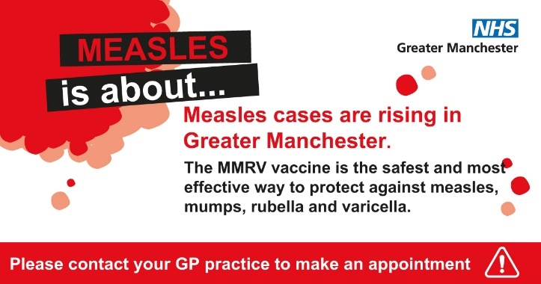

Supporting copy:
Measles can be dangerous.
Some people get very sick from measles and can develop pneumonia and meningitis. One in five people with measles will go to hospital and in very rare cases people can die. Ask your GP practice about your free MMR/MMRV vaccination.
(*Either MMR or MMRV vaccinations according to age)

Link in comment:
Please visit our website for the latest information about Measles - www.gmintegratedcare.org.uk/measles

Alt text for image:
Measles is about. Measles cases are rising in Greater Manchester. The MMR/MMRV vaccine is the safest and most effective way to protect against measles, mumps, and rubella. Please contact your GP practice to make an appointment.

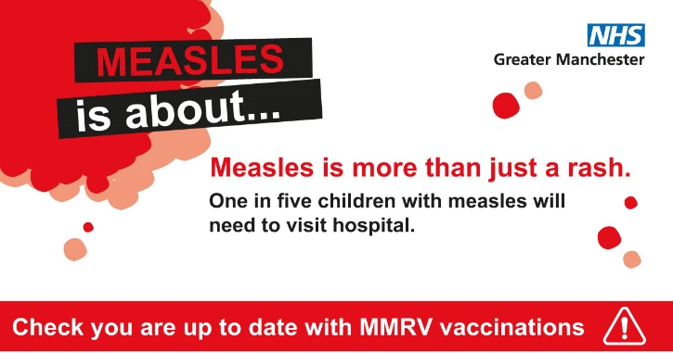

Supporting copy
Measles is more than just a rash.
It can be very serious, so make sure you’re up to date with MMR/MMRV vaccinations. Ask your GP about catch up jabs if you need them.
(*Either MMR or MMRV vaccinations according to age)

Link in comment:
You can find more information about measles on our website - www.gmintegratedcare.org.uk/measles

Alt text for image:
Measles is about. Measles is more than just a rash. One in five children with measles will need to visit hospital. Check you are up to date with MMR/MMRV vaccinations.

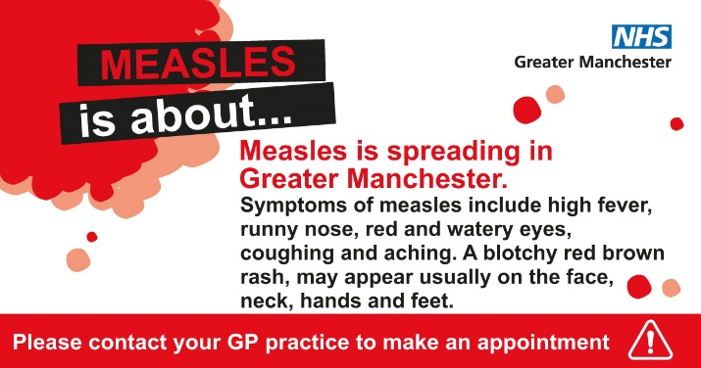

Supporting copy
If you have symptoms of measles, stay at home and phone your GP or NHS 111 for advice. Stay away from GP surgeries, A&E departments, and other health care venues.
People with measles should stay off nursery, school, or work until at least 4 days from when the rash first appears.

Link in comment:
More information about measles can be found on our dedicated web page - www.gmintegratedcare.org.uk/measles

Alt text for image:
Measles is about. Measles is spreading in Greater Manchester. Symptoms of measles include high fever, runny nose, red and watery eyes, coughing and aching. A blotchy red brown rash may appear usually on the face, neck, hands, and feet. Please contact your GP practice to make an appointment.

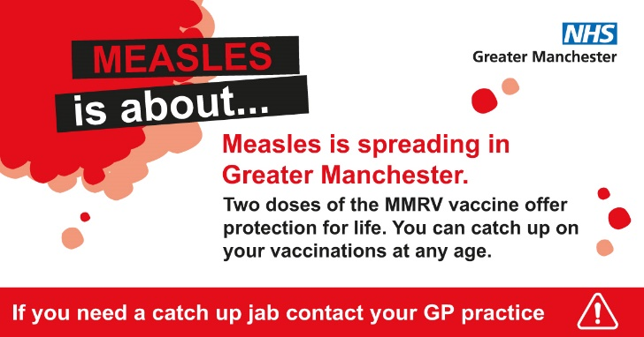

Supporting copy:
Two doses of the MMR/MMRV vaccine offer protection for life against measles, mumps, rubella and varicella.
Are you and your loved ones protected? If you’re not sure, contact your GP about getting catch up jabs.
(*Either MMR or MMRV vaccinations according to age)

Link in comment:
Please visit our website for the latest information about Measles - www.gmintegratedcare.org.uk/measles

Alt text for image:
Measles is about. Measles is spreading in Greater Manchester. Two doses of the MMR/MMRV vaccine offer protection for life. You can catch up on your vaccinations at any age.

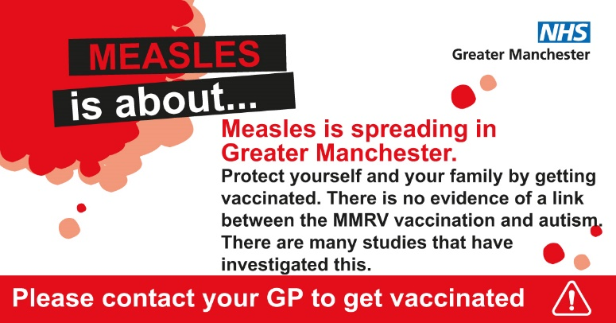

Supporting copy
Protect yourself and your family but having the MMR/MMRV vaccination. The vaccination is safe and effective.
There is no link between the MMR/MMRV vaccination and autism and there are studies to prove this.
(*Either MMR or MMRV vaccinations according to age)

Link in comment:
Please visit our website for the latest information about Measles - www.gmintegratedcare.org.uk/measles

Alt text for image:
Measles is about. Measles is spreading in Greater Manchester. Protect yourself and your family by getting vaccinated. There is no evidence of a link between the MMR/MMRV vaccination and autism. There are many studies that have investigated this. Please contact your GP to get vaccinated.

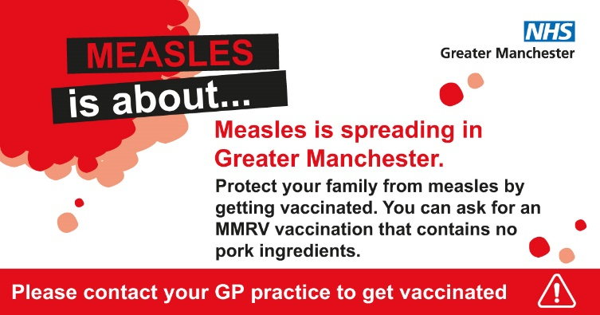

Supporting copy
Protect yourself and your family by getting vaccinated.
Did you know you can ask for a vaccine that contains no pork products. Please let your GP practice know you want this vaccine when you book your appointment so they can make sure it is available.
(*Either MMR or MMRV vaccinations according to age)

Link in comment:
Please visit our website for the latest information about Measles - www.gmintegratedcare.org.uk/measles

Alt text for image:
Measles is about. Measles is spreading in Greater Manchester. Protect your family from measles by getting vaccinated. You can ask for an MMR/MMRV vaccination that contacts no pork ingredients. Please contact your GP practice to get vaccinated.

