Communications toolkit: Get To Know Where To Go – Winter 2024

Introduction:
Winter can be a difficult time. Health services come under increased pressure and we’re all more likely to see a dip in our health and wellbeing – especially those who are more vulnerable. So, it’s more important than ever that people know what to do and get to know where to go if they are unwell or need extra help and support.

How you can get involved:
You can help by sharing information on your website, social media channels and in your newsletter (if you have one). We have produced this toolkit especially for use by other organisations so you can help to support both your local community and the NHS this winter. More resources including videos and artwork in languages other than English are currently being developed we will upload these to the campaign resource centre as soon as they are ready.
This toolkit contains:
- Text for an article to be used on a website or in a newsletter
- Animated images for electronic screens
- Text and images to share on your social media channels

We’d love it if you could look out for posts on our social media channels and share them to your followers. Search for #GTKWTG.
If you don’t already follow us, you'll find us here:
Facebook @NHSGreaterManchester
X @NHS_GM
Instagram @nhs_gm

Newsletter/Website copy

Get to know where to go this winter
With colder temperatures and shorter days - plus all the coughs, colds and bugs doing the rounds - winter can be tough for us all. Our NHS also comes extra under pressure too so it’s more important than ever to know what to do and where to go if you’re feeling under the weather.
Get to know where to go and you can find the help and support you need quicker. To find the right service for your needs, go to the ‘Get To Know Where To Go’ page on the NHS Greater Manchester website.
Your local pharmacy can give expert advice on minor illnesses, including over the counter medicines. Did you know they can now provide prescription medicine for some conditions, without a GP appointment? For more information, go to the ‘Think Pharmacy First page on the NHS Greater Manchester website.
If you’re not sure what to do, NHS 111 can help. Go to https://111.nhs.uk/ (over 5 years of age only) or call NHS 111. You will be directed to the best place to get help for your symptoms.
Your ‘just in case’ winter contact list:
Teeth: Greater Manchester Urgent Dental Service – call 0333 332 3800. Open 8am to 10pm every day, including weekends and bank holidays.
Eyes: Greater Manchester Urgent Eye Care Service – go to www.primaryeyecare.co.uk/find-a-practice. Available all week, including weekends and bank holidays.
Mental health: Call 111 and choose option 2 if you, or someone you know, is experiencing a mental health crisis. Available 24/7 day and night, it's for all ages, including children and young people.

Text and images for social media
To download all the available images, please visit the Campaign Resource Centre on the NHS GM website. Please do not copy and paste the images in the table below as they are lower quality.
A table including images and text for social media.
Image | Long text for social media – Facebook / Instagram | Short text for social media - X | Alt text for the image
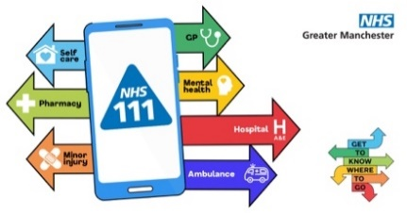 | If you need urgent medical help but you’re not sure where to go, call 111 for free or go online to 111.nhs.uk (NHS 111 online is for people aged 5 and over).  #GTKWTG | If you need urgent medical help but you’re not sure where to go, call 111 for free or go online to 111.nhs.uk (NHS 111 online is for people aged 5 and over).  #GTKWTG | Visual contains image of a smartphone with 111 displayed on it. Arrows are coming out of it in different colours, indicating different health services.  Text reads: Self-care, Pharmacy, Minor injury, Ambulance, GP, Mental health, Hospital. Not sure where to go? NHS 111 can help… Get to know where to go.
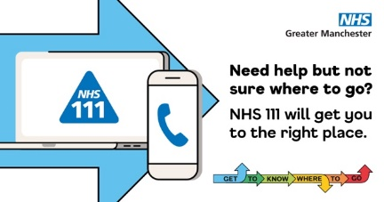 | If you need urgent medical help #NHS111 can give you expert advice and book you an appointment at your local urgent treatment centre, emergency dental service, pharmacy or another local service.  #NHS111 - there for you 24/7, 365 days a year | If you need urgent medical help #NHS111 can give you and expert advice book you an appointment at your local urgent treatment centre, emergency dental service, pharmacy or another local service.  #NHS111 - there for you 24/7, 365 days a year | Visual contains a large blue arrow with a laptop and mobile phone inside. The laptop screen is showing the NHS 111 logo.  Text reads: Need help but not sure where to? NHS 11 will get you to the right place.
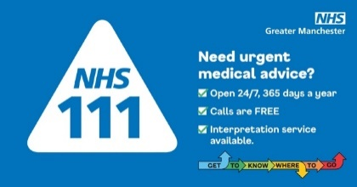 | If you need urgent medical help #NHS111 is there for you 24/7, 365 days a year. Calls are free and if you need help from an interpreter just ask.  #GTKWTG | If you need urgent medical help #NHS111 is there for you 24/7, 365 days a year. Calls are free and if you need help from an interpreter just ask.  #GTKWTG | Visual contains the NHS 111 logo.  Text reads: Need urgent medical advice?  Open 24/7, 365 days a year  Calls are free  Interpretation service available
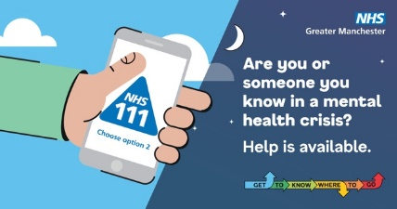 | Call 111 and choose the mental health option (option 2) if you, or someone you know, is experiencing a mental health crisis.  Available 24/7 day and night, it's for all ages, including children and young people.  Mental health advisors are there to listen and help you find the right support.  #NHS111 #GTKWTG | Call 111 and choose the mental health option (option 2) if you, or someone you know, is experiencing a mental health crisis.  Mental health advisors are available 24/7 to listen and help you find the right support.  #NHS111 #GTKWTG | Visual is split in half. Half of the background is showing a daytime, blue and cloudy sky, the other half is a nighttime starry sky. There is an hand reaching in holding a mobile phone that has the NHS 111 logo on the screen.  Text reads: Are you or someone you know in a mental health crisis? Help is available.
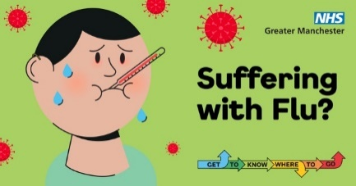 | Antibiotics don’t work for viral infections like flu.  If you have flu, the best thing to do is rest, keep warm, get plenty of sleep and drink lots to stay hydrated. Paracetamol or ibuprofen can help to lower your temperature and treat your aches and pains.  #GTKWTG | Antibiotics don’t work for viral infections like flu.  If you have flu, the best thing to do is rest, keep warm, get plenty of sleep and drink lots to stay hydrated. Paracetamol or ibuprofen can help to lower your temperature and treat your aches and pains.  #GTKWTG | Visual contains an unwell person, sweating with a thermometer in their mouth.  Text reads: Suffering with Flu?
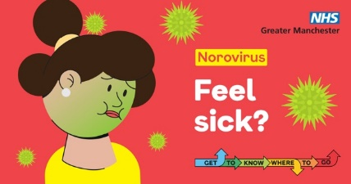 | Norovirus is a winter stomach bug that causes vomiting and diarrhoea. It’s a nasty bug, but usually goes away in around 2-3 days.  Make sure you stay hydrated by drinking lots and get plenty of rest. Stay off school or work until you have not been sick or had diarrhoea for at least 2 days, so you don’t pass it on to others. Please don’t visit hospitals or care homes while you are unwell.  #GTKWTG | Norovirus is a winter stomach bug. It’s not very nice, but usually goes away in 2-3 days.  Make sure you stay hydrated by drinking lots and rest. Stay off school or work until you have not been sick or had diarrhoea for at least 2 days, so you don’t pass it on to others.  #GTKWTG | Visual contains a person whose facing is turning green because they feel sick.  Text reads: Norovirus. Feel sick?
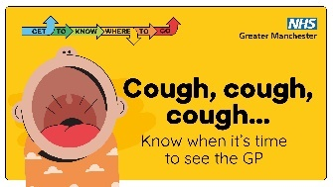 | Bronchiolitis is a very common chest infection mostly in children aged two and under.  The early symptoms are similar to a common cold, but can develop into a dry cough that lasts a long time, dry nappies, a fever or feeling hot to the touch, being too tired or breathless to feed, and a wheezing when breathing.  It is not usually serious and can be treated at home, but if you're worried, contact your GP.  For more information search NHS bronchiolitis  #GTKWTG | Bronchiolitis is a common chest infection which affects children aged 2 and under  Symptoms include a dry cough that lasts a long time, a fever and wheezing.  It can usually be treated at home, but if you're worried, contact your GP.  For more information search NHS bronchiolitis  #GTKWTG | Visual contains image of baby crying.  Text reads: Cough, cough, cough… know when it’s time to see the GP
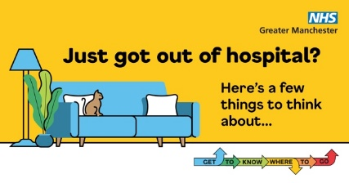 | If you or a loved one have been in hospital for a while, coming home can be a bit of a worry.  Know that if the hospital have said you are ready to come home, home really is the best place for you to recover  Rest as much as you can, make sure you have any prescription medicines you need and ask for help with tasks such as the weekly food shop and dog walking.  #GTKWTG | Coming home from hospital can be a worry.  If the hospital have said you are ready to come home, home really is the best place for you to recover.  Make sure to rest, have any prescription medicines you need and ask for help with day-to-day tasks.  #GTKWTG | Visual contains a blue sofa with a cat sat on it, with a lamp and house plant to the side.  Text reads: Just got out of hospital? Here’s a few things to think about…
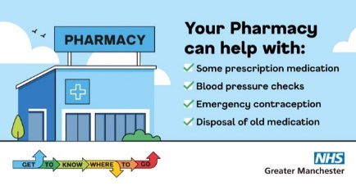 | If you have a minor health concern, don’t wait to see your GP. Pharmacists can offer advice on many illnesses as well as offering some prescription medicine, blood pressure checks, emergency contraception and disposal of your old medication.  To find your nearest pharmacy search: NHS find a pharmacy | If you have a minor health concern, don’t wait to see your GP. Pharmacists can offer advice on many illnesses as well as offering some prescription medicine.  To find your nearest pharmacy search: NHS find a pharmacy | Visual contains an image of pharmacy.  Text reads: Your Pharmacy can help with:  Some prescription medication  Blood pressure checks  Emergency contraception  Disposal of old medication
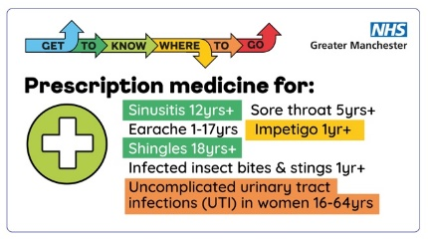 | Don’t forget your pharmacy can offer prescription medicine for these seven common conditions without you seeing a GP:  Sinusitis  Sore throat  Earache  Infected insect bites and stings  Impetigo  Shingles  Uncomplicated urinary tract infections (UTI) in women 16-64 yrs.  #GTKWTG | Don’t forget your pharmacy can offer prescription medicine for these 7 common conditions without you seeing a GP:  Sinusitis  Sore throat  Earache  Infected insect bites and stings Impetigo  Shingles  Uncomplicated urinary tract infections (UTI) in women 16-64 yrs.  #GTKWTG | Visual shows image of a white cross in a green circle.  Text reads: Prescription medicine for: Sinusitis 12yrs+, Sore throat 5yrs+, Earache 1-17yrs, Infected insect bites and stings 1yr+, Impetigo 1yr+, Shingles 18yrs+, Uncomplicated urinary tract infections (UTI) in women 16-64 yrs. Your pharmacy can help. Get To Know Where To Go.
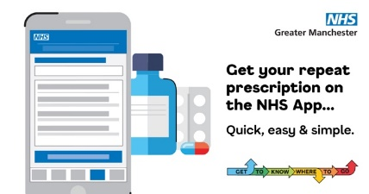 | Did you know can your order and view all your repeat prescriptions on the NHS app. You can also choose which pharmacy to pick them up from  Top tip: Having quick access to a list of all your medications is really handy if you need to tell someone what medications you are on, like a pharmacist of other healthcare professional.  #GTKWTG | Did you know can your order and view all your repeat prescriptions on the NHS app. You can also choose which pharmacy to pick them up from  #GTKWTG | Visual contains a mobile phone, with a medication bottle, blister pack and tablet behind it.  Text reads: Get your repeat prescriptions on the NHS App…  Quick, easy and simple.
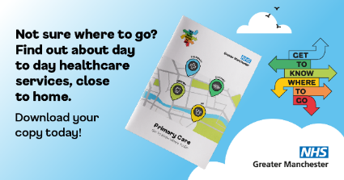 | Deciding where to go to get the help you need can be tricky. Check out the primary care booklet to help you get to know where to go.  It explains about the services available, what illnesses or health problems they can help with and, how to access them, making it easier to choose the right service for you.  Visit: https://gmintegratedcare.org.uk/GTKWTG to download the booklet.  #GTKWTG | Deciding where to go to get the help you need can be tricky.  Download our handy booklet from here: https://gmintegratedcare.org.uk/GTKWTG  #GTKWTG | Visual contains a picture of the primary care booklet in a cloudy sky. The Get To Know Where To Go logo is to the right.  Text reads: Not sure where to go? Find out about day to day healthcare services, close to home.  Download your copy today!

