NHS Greater Manchester Communications toolkit: Patient led ordering of medicines

Introduction:
The way repeat prescriptions are ordered is changing. For most patients, this means that instead of their local pharmacy ordering their prescriptions for them, they will need to request medication directly from their GP practice.
Patients will be able to order repeat medication using the NHS app – this is the safest and easiest way. If patients do not wish to use the NHS app, they should refer to their GP practice’s website or speak to a member of the practice’s team.
Practices will work with their local community pharmacies to set their own date for this change. Patients who already take their repeat prescription request slips into the GP practice or order their repeat medication online are not affected.
GP practices will work closely with pharmacies to make that patients who aren’t able to order their repeat medication by any of the recommended routes, will get support appropriate for their personal needs. This could mean that pharmacies continue to order on behalf of some patients, where all partners agree this is the best solution for a particular individual.
This change aims to:
- Reduce medicine waste – the way prescriptions are currently ordered means that many medicines are ordered but not needed.
- Give patients better control over the ordering of their own medication.
- Improve safety by avoiding stockpiling of medication and prevent medication that has been stopped from being re-ordered by mistake.
- Save GP practice time (especially if prescriptions are ordered online) with less time spent chasing and processing prescriptions and answering the phone to queries and complaints.

Communications aims and objectives
- Raise awareness of an upcoming change to medicine ordering and ensure patients are prepared.
- Raise awareness of the benefits of online ordering of medicines.
- Encourage more patients to download and use the NHS App – especially when ordering repeat prescriptions.

Key messages
- The way repeat prescriptions are ordered is changing. Soon most patients will no longer be able to order regular medicines on repeat prescription from their local pharmacy.
- Patients are able to request their own medication directly from their GP practice. Ordering online is the safest and easiest way to do this.
- The safest and easiest way to request regular medicines on repeat prescription is online via the NHS App. If patients do not wish to use the NHS app, they should refer to their GP practice’s website or speak to a member of the practice’s team.
- Ordering your own prescriptions puts you in control. By only ordering the medicines you need, you can help to reduce waste and save money that can be spent on other NHS services.
- It’s best to order your repeat prescription 7 working days in advance. Don’t wait until you’re just about to run out! It can take time for your request to be approved by your GP practice - especially when they’re busy.
- Your GP practice will let you know when changes to the ordering of repeat prescriptions are being introduced at your practice. They will let you know in advance, so look out for a text, email or letter with further details.
- You can order repeat prescriptions quickly and easily online via the NHS App. It can be downloaded to your mobile phone via the Apple Store or Google Play.
- If you don’t want to download an app to your phone, or would rather use a PC, you can set up an NHS account and log in via the website. You can order repeat prescriptions online in just the same way.
- If you already order your repeat prescriptions online, via the NHS App or another online platform used by your GP practice, these changes will not affect you.
- Take control of your repeat prescriptions – go online! It’s quicker, easier, there’s less waste, and you’re dealing directly with your GP practice so it’s less hassle if there’s a problem.
- GP practices will work closely with pharmacies to make that patients who aren’t able to order their repeat medication by any of the recommended routes, will get support appropriate for their personal needs. This could mean that pharmacies continue to order on behalf of some patients, where all partners agree this is the best solution for a particular individual.
- If you would like to order your repeat prescriptions online but you’re struggling to set up the NHS App, you can contact your GP practice or local pharmacy for advice and support.
- The NHS App allows you to access a range of NHS services. You can book and manage appointments, view your GP health record, find your NHS number – and more.

Available materials / assets
NHS Greater Manchester has produced a video featuring patients, a GP, a pharmacist and community digital facilitators talking about the benefits of using the NHS app, including sharing their own experiences.
NHS England has developed a range of promotional materials and digital assets:
- Patient leaflets and posters
- Images for the web and digital displays
- Images for social media
- Message templates and website text for practices
They can be downloaded from the NHS Digital website.

How you can get involved:
- Use the videos and social media assets to schedule posts on your channels
- Promote the campaign using the suggested copy for your newsletters
- Share this toolkit with partner organisations and with your stakeholder lists
We’d love it if you could look out for posts on our social media channels and share them to your followers.
If you don’t already follow us, you'll find us here:
- Facebook @NHSGreaterManchester
- X @NHS_GM
- Instagram @nhs_gm

Newsletter/Website copy

Ordering repeat prescriptions via the NHS App
The way repeat prescriptions are ordered is changing.
For most patients, this means that instead of their local pharmacy ordering their prescriptions for them, they will need to request medication directly from their GP practice.
The NHS App is the safest and easiest way for patients to request their repeat prescription – giving them more control over their healthcare and taking away the hassle of unnecessary trips to the GP practice.
The app is easy to use, with a ‘Help’ section within the app to guide patients if they hit a problem and allows patients to choose where their prescription is sent. Patients can also order their prescription at any time that suits them. There’s no need to wait to join a telephone queue or wait until the GP surgery opens.
GP practices will set their own date for when these changes happen. They will let patients know in advance, so look out for a text, email or letter with further details. This means you will have plenty of time to set up online prescription ordering or to talk through any concerns you may have with your practice.
Patients who are unable to order their own medication by any of the recommended routes, are vulnerable and/or housebound, will be supported by their GP and local pharmacy.

What do I do now?
- Look out for information from your GP practice with a ‘go live’ date for changes to repeat prescription ordering.
- Download the NHS App. You can do this via the Apple Store or Google Play. You can set up an NHS account and log in via the NHS App webpage if you would prefer to use a PC.
- Set up online prescription ordering.
- Make sure your GP practice is aware, if you, or someone you care about, may struggle to order their own prescriptions.
If you already order your repeat prescriptions online, via the NHS App or another online platform used by your GP practice, these changes will not affect you.
You can find out more on the NHS App webpage.

Text and images for social media
To download all the available images, please visit the Campaign Resource Centre on the NHS GM website. Please do not copy and paste the images in the table below as they are lower quality.
Long copy - Facebook | X copy | Asset | Alt copy
You can request your repeat prescription and have it sent to the most convenient pharmacy for you via the NHS app.  To find out more, search: NHS app | You can request your repeat prescription and have it sent to the most convenient pharmacy for you via the NHS app.  To find out more, search: NHS app | 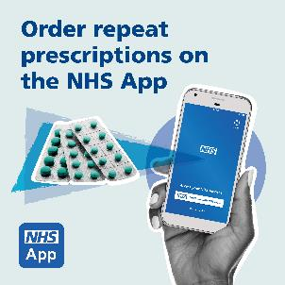 | Visual contains image of a smartphone with the NHS App on the screen and three blister packs full of tablets.  Text reads: Order repeat prescriptions on the NHS App.
The NHS app is the best way to order your repeat prescription.  It’s quick and convenient and puts you in control of your medication.  To find out more, search: NHS app | The NHS app is the best way to order your repeat prescription.  It’s quick and convenient and puts you in control of your medication.  To find out more, search: NHS app |  | Visual contains image of a smartphone with the NHS App on the screen and three blister packs full of tablets.  Text reads: Order repeat prescriptions on the NHS App.
Do you know you can order your repeat prescriptions quickly and easily by using the NHS app?  Skip unnecessary trips or phone calls to your GP practice and have your medication sent to your local pharmacy.  Download the NHS app through Apple Store or Google Play. | Do you know you can order your repeat prescriptions quickly and easily by using the NHS app?  Skip unnecessary trips or phone calls to your GP practice and have your medication sent to your local pharmacy.  Download the NHS app through Apple Store or Google Play. |  | Visual contains image of a smartphone with the NHS App on the screen and three blister packs full of tablets.  Text reads: Order repeat prescriptions on the NHS App.
Ordering your own prescriptions via the NHS app puts you in control.  By only ordering the medicines you need, you can help to reduce waste and save money that can be spent on other NHS services.  To find out more, search: NHS app | Ordering your own prescriptions via the NHS app puts you in control.  By only ordering the medicines you need, you can help to reduce waste and save money that can be spent on other NHS services.  To find out more, search: NHS app |  | Visual contains image of a smartphone with the NHS App on the screen and three blister packs full of tablets.  Text reads: Order repeat prescriptions on the NHS App.
The safest, easiest and quickest way to request regular medicines on repeat prescription is online.  You can use the NHS app, or another online platform used by your GP practice, to do this.  The NHS app can be downloaded for free to your mobile phone via the Apple Store or Google Play.  To find out more, search: NHS app | The safest, easiest and quickest way to request repeat prescriptions is online.  You can use the NHS app, or another online platform used by your GP practice.  The NHS app can be downloaded for free via the Apple Store or Google Play.  To find out more, search: NHS app |  | Visual contains image of a smartphone with the NHS App on the screen and three blister packs full of tablets.  Text reads: Order repeat prescriptions on the NHS App.
Ordering your own repeat prescriptions via the NHS app puts you in control.  You can order what you need, when you need it.  It’s quicker and easier.  There's less waste.  To find out more, search NHS app | Ordering your own repeat prescriptions via the NHS app puts you in control.  You can order what you need, when you need it.  It’s quicker and easier.  There's less waste.  To find out more, search NHS app |  | Visual contains image of a smartphone with the NHS App on the screen and three blister packs full of tablets.  Text reads: Order repeat prescriptions on the NHS App.
The NHS app is the safest and easiest way to order your repeat prescription.  Not sure what to do?  Watch this video for a step-by-step guide.  To find out more, search: NHS app | The NHS app is the safest and easiest way to order your repeat prescription.  Not sure what to do?  Watch this video for a step-by-step guide.  To find out more, search: NHS app | How to order your repeat prescription on the NHS app video  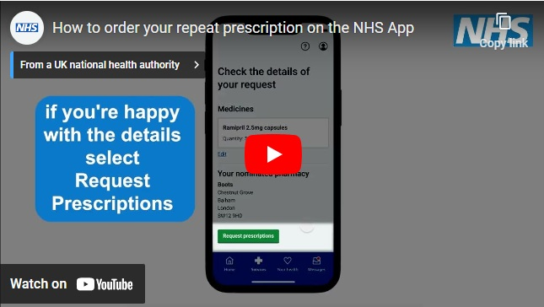 | Visual contains a still of a video. There is a phone, which screen is showing the NHS app.  Text reads: If you’re happy with the details select Request Prescriptions
Fast, easy and convenient. Ordering your repeat prescriptions via the NHS app is simple.  This video takes you through each step.  To find out more, search NHS app | Fast, easy and convenient. Ordering your repeat prescriptions via the NHS app is simple.  This video takes you through each step.  To find out more, search NHS app | How to order your repeat prescription on the NHS app video | Visual contains a still of a video. There is a phone, which screen is showing the NHS app.  Text reads: If you’re happy with the details select Request Prescriptions
Did you know using the NHS app means you can choose which pharmacy to collect your medicine from when ordering a repeat prescription?  Very handy if you're away from home or moving house!  Watch this step-by-step video guide to find out how easy it is to order your regular medicines using the NHS app. | Did you know using the NHS app means you can choose which pharmacy to collect your medicine from when ordering a repeat prescription?  Very handy if you're away from home or moving house!  Watch this step-by-step video guide to find out more. | How to order your repeat prescription on the NHS app video | Visual contains a still of a video. There is a phone, which screen is showing the NHS app.  Text reads: If you’re happy with the details select Request Prescriptions
Have you tried ordering your repeat prescription on the NHS app yet?  Hear from patients, a pharmacist and a GP in our new video - and find out why you should give it a try.  You can download the NHS app for free to your mobile phone via the Apple Store or Google Play. | Have you tried ordering your repeat prescription on the NHS app yet?  Hear from patients, a pharmacist and a GP in our new video - and find out why you should give it a try.  You can download the NHS app for free to your mobile phone via the Apple Store or Google Play. | NHS app video  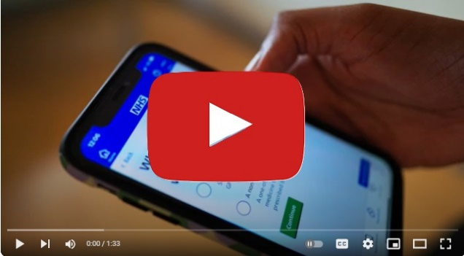 | Visual is a still of the NHS app video. There is a hand holding a phone which screen is showing the NHS app. There is a red play button over the top.
Watch our video to hear a GP, a pharmacist and patients talk about the benefits of using the NHS app to order repeat prescriptions.  Find out more about the NHS app and how it can make managing your healthcare easier. Search: NHS app. | Watch our video to hear a GP, a pharmacist and patients talk about the benefits of using the NHS app to order repeat prescriptions.  Find out more about the NHS app and how it can make managing your healthcare easier. Search, NHS app. | NHS app video | Visual is a still of the NHS app video. There is a hand holding a phone which screen is showing the NHS app. There is a red play button over the top.
“I would have had to go to the medical centre and wait in the queue, but this way it’s simple and takes a lot of burden away from you."  Martin from Stockport talks about why he orders his repeat prescriptions via the NHS app.  Watch our latest video to hear more about Martin's experiences, and those of other patients who use the NHS app.  To find out more, search: NHS app | “I would have had to go to the medical centre and wait in the queue, but this way it’s simple and takes a lot of burden away from you."  Martin from Stockport explains why he orders repeat prescriptions via the NHS App.  Watch the video to find out more. | NHS app video | Visual is a still of the NHS app video. There is a hand holding a phone which screen is showing the NHS app. There is a red play button over the top.
Please contact the NHS GM campaigns team if you have any questions or experience any problems downloading from the links provided – gmhscp.gm-campaigns@nhs.net.

