Communications toolkit: Get to Know Where to Go: Spring 2025

Introduction:
The NHS is often busier during bank holiday periods and can come under increased pressure. With lots of bank holidays coming up during April and May, NHS Greater Manchester wants to ensure that residents are well prepared and know where to go to get the care they need. This will not only help to ease the strain on health services but also allow people to get help more quickly.

How you can get involved:
You can help by sharing information on your website, social media channels and in your newsletter (if you have one). We have produced this toolkit especially for use by other organisations so you can help to support both your local community and the NHS.
This toolkit covers:
- Using NHS 111 to get medical help and advice.
- When to order your repeat prescriptions so you have enough medication over the long weekends.
- Changes to pharmacy opening times on bank holidays.
- What urgent care services are available including dental, eyecare and mental health.
- Mental health support during exam season.
We’d love it if you could look out for posts on our social media channels and share them to your followers. Search for #GTKWTG.
If you don’t already follow us, you'll find us here:
Facebook @NHSGreaterManchester
X @NHS_GM
Instagram @nhs_gm

Newsletter/Website copy

Top tips for the bank holiday from NHS Greater Manchester
That time of year is approaching – the days are getting longer, we’re starting to defrost from winter and there are a string of bank holidays to look forward to. Spring can however be a pressured time for health services.
With the bank holidays only weeks away, NHS Greater Manchester is planting the seed to make sure that everyone knows where to go for the care they need, and there are a few important tips to remember:
- Do you take regular medicines on a repeat prescription? If so it’s a good idea to check how much you have at home before the long weekend. If you need to order more, put your request in at least two weeks before you expect to run out of a particular medicine, to avoid any complications or delays.
- Did you know your pharmacist can give you expert advice on treating minor illnesses or injuries? So, if you find yourself with a sore throat or your little one is teething, your community pharmacy can see you without an appointment and recommend over-the-counter medicines they can also prescribe medicines for some conditions too. Just remember to check their bank holiday opening times.
- Not sure which NHS service you need? When you use the right NHS service, you get the right treatment sooner. If you’re not sure what to do or where to go, go to 111.nhs.uk. It’s available 24/7, 365 days a year.
- Need urgent care? Whether you have a pain in your gums, have a sudden change in your vision or need support for a mental health crisis, there are local services there to help. Find the right urgent and emergency services for your needs.

Text and images for social media
To download all the available images, please visit the Campaign Resource Centre on the NHS GM website. Please do not copy and paste the images in the table below as they are lower quality.
We have given you some suggestions for hashtags (#) to use in your social media posts.
Image | Long text for social media – Facebook/Instagram | Short text for social media – X | Alt text for the image
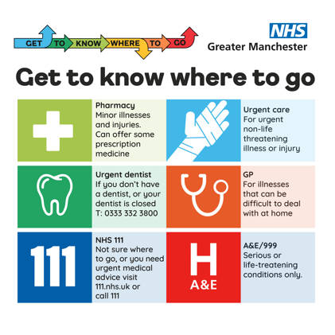 | Get to know where to go and help us save our emergency departments for those who need it most. #NHS111 #GM #HealthAdvice #GTKWTG | Get to know where to go and help us save our emergency departments for those who need it most. #NHS111 #GM #HealthAdvice #GTKWTG | In the top left corner is the campaign logo. In the top right corner is the NHS GM logo.  Text at the top of the image reads ‘Get to know where to go’.  The main image contains 12 multi-coloured squares with information on pharmacy, urgent dental services, NHS 111, urgent care, GP and A&E.
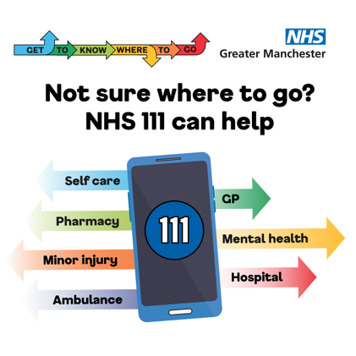 | If you need urgent medical help but you're not sure where to go, use 111. Go online, use the NHS App or call.  #NHS111 #GM #healthadvice #NHSApp #GTKWTG | If you need urgent medical help but you're not sure where to go, use 111 to get advice and directed to the right place for you. Go online, use the NHS App or call.  #NHS111 #GM #healthadvice #NHSApp #GTKWTG | In the top left corner is the campaign logo. In the top right corner is the NHS GM logo.  Text at the top of the image reads ‘Not sure where to go? NHS 111 can help’.  There’s a mobile phone will ‘111’ on the screen. Seven multi-coloured arrows are coming out the phone in different directions with key words such as ‘self care’ and ‘mental health’ in the middle.
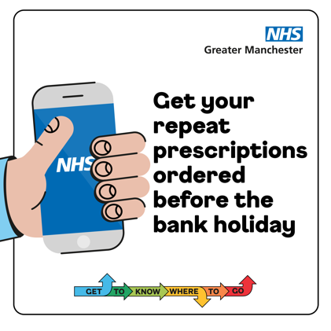 | Avoid a bank holiday emergency. Order your repeat prescriptions in plenty of time so you don’t run out.  The NHS app is the safest and easiest way to order your repeat prescription.  #bankholiday #presciption, #pharmacy #NHSApp #GM #GTKWTG | Avoid a bank holiday emergency. Order your repeat prescriptions in plenty of time so you don’t run out.  The NHS app is the safest and easiest way to order your repeat prescription.  #bankholiday #presciption, #pharmacy #NHSApp #GM #GTKWTG | In the top right corner is the NHS GM logo.  Text to the right-hand-side reads ‘Get your repeat prescriptions ordered before the bank holiday’. To the left is a hand holding a mobile phone which as ‘NHS’ on the screen.  The campaign logo is at the bottom.
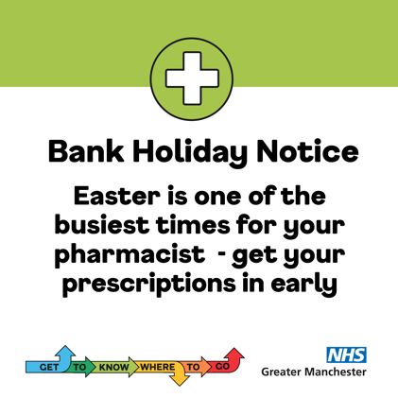 | We hope you’re looking forward to the bank holiday!  Remember, if you have a repeat prescription, check how much medicine you have at home. If you need it, order more well in advance so you aren’t without over the long weekend.  #NHS #GM #prescriptions #bankholiday2025 #GTKWTG | We hope you’re looking forward to the bank holiday!  If you have a repeat prescription, it’s a good idea to check how much medicine you. If you need it, order more in advance so you aren’t without over the long weekend.  #NHS #GM, #prescriptions, #bankholiday2025 #GTKWTG | There’s a white cross at the top of the image. Beneath that, text reads ‘Bank holiday notice. Easter is on the busiest times for your pharmacist – get your prescriptions in early’.  The campaign logo is in the bottom left corner and the NHS logo is the bottom right.
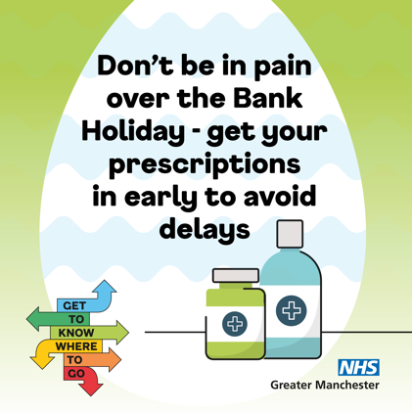 | We hope you’re looking forward to the bank holiday!  Remember, if you have a repeat prescription, check how much medicine you have at home. If you need it, order more well in advance so you aren’t without over the long weekend.  #NHS #GM #prescriptions #bankholiday2025 #GTKWTG | We hope you’re looking forward to the bank holiday!  Remember, if you have a repeat prescription, check how much medicine you have at home. If you need it, order more well in advance so you aren’t without over the long weekend.  #NHS #GM #prescriptions #bankholiday2025 #GTKWTG | The background is an Easter egg. Text on top reads ‘Don’t be in pain over the Bank Holiday – get your prescriptions in early to avoid delays’.  Two bottles of medicines are beneath the text.  The campaign logo is in the bottom left-hand corner and the NHS logo is in the bottom right.
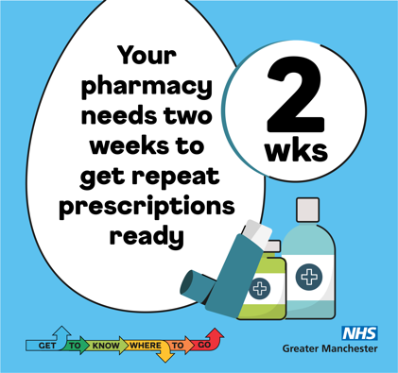 | It's not long until the bank holiday weekend.  Your pharmacy needs two weeks to get your repeat prescription ready, so order your prescriptions in plenty of time so you can enjoy the long weekend and remember, some pharmacies might have different opening hours.  #Pharmacy #bankholiday2025 #NHS, #GM #prescriptions #GTKWTG | It's not long until the #bankholidayweekend.  Your pharmacy needs two weeks to get your repeat prescription ready, so order your prescriptions in plenty of time. Remember, some pharmacies might have different opening hours.  #Pharmacy #bankholiday2025 #NHS, #GM #prescriptions #GTKWTG | Text displayed in an Easter egg reads ‘Your pharmacy needs two weeks to get repeat prescriptions ready’. Next to that in a circle it says ‘2 wks’.  Beneath the text are a couple of medicine bottles and an inhaler.  The campaign logo is in the bottom left-hand corner and the NHS logo is in the bottom right.
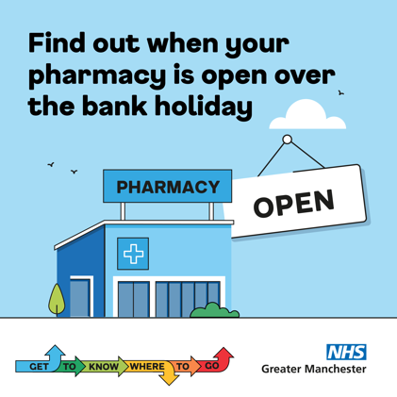 | Need help over the bank holiday weekend but unsure which pharmacy is open closest to you?  Check your local pharmacy opening times and know where to go for advice when needed: www.gmintegratedcare.org.uk/bankholidaypharmacy/  #NHS #GM #pharmacy #bankholiday2025 #GTKWTG | Need help over the bank holiday weekend but unsure which pharmacy is open closest to you?  Check your local pharmacy opening times and know where to go for advice when needed: www.gmintegratedcare.org.uk/bankholidaypharmacy/  #NHS #GM #pharmacy #bankholiday2025 #GTKWTG | Main image is of a pharmacy with a big ‘open’ sign next to it.  Text above the pharmacy says ‘Find out when your pharmacy is open over the bank holiday’.  The campaign logo is in the bottom left-hand corner and the NHS logo is in the bottom right.
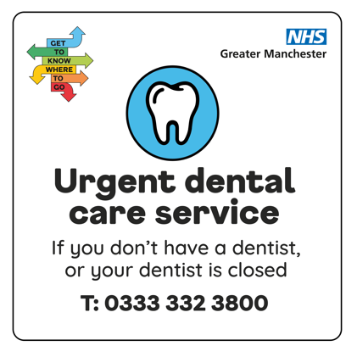 | Pain in your mouth, teeth or gums? Time to contact your dentist. If they are closed or you don’t have a regular dentist call the Greater Manchester Urgent Dental Care Service on 0333 3323800.  #NHS #GM #dentist #toothache #GTKWTG | Pain in your mouth, teeth or gums? Time to contact your dentist. If they are closed or you don’t have a regular dentist call the Greater Manchester Urgent Dental Care Service on 0333 3323800.  #NHS #GM #dentist #toothache #GTKWTG | Tooth in a blue circle. Beneath that, text reads Urgent dental care service. If you don’t have a dentist, or your dentist is closed call 03333323800.  The campaign logo is in the top left-hand corner and the NHS logo is in the top right.
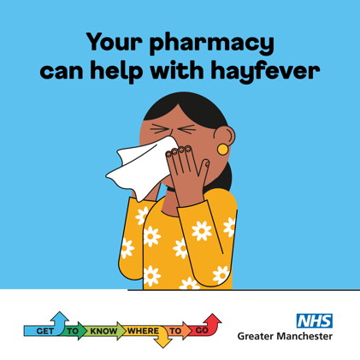 | We’re heading into #hayfever season but don’t let #allergies get in your way of enjoying springtime.  Most allergies can usually be treated with antihistamine medication, available at pharmacies.  Talk to a pharmacist for advice: www.nhs.uk/service-search/pharmacy/find-a-pharmacy #GTKWTG | We’re heading into #hayfever season but don’t let #allergies get in your way of enjoying springtime.  Most allergies can usually be treated with antihistamine medication, available at pharmacies.  Talk to a pharmacist for advice: www.nhs.uk/service-search/pharmacy/find-a-pharmacy #GTKWTG | Person blowing nose into a tissue. Text above says ‘Your pharmacy can help with hayfever’.  The campaign logo is in the bottom left-hand corner and the NHS logo is in the bottom right.
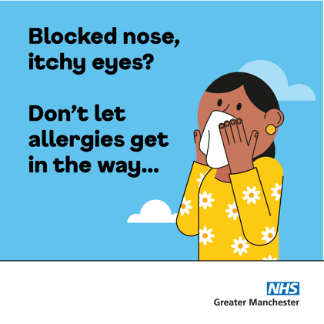 | We’re heading into #hayfever season but don’t let #allergies get in your way of enjoying springtime.  Most allergies can usually be treated with antihistamine medication, available at pharmacies.  Talk to a pharmacist for advice: www.nhs.uk/service-search/pharmacy/find-a-pharmacy #GTKWTG | We’re heading into #hayfever season but don’t let #allergies get in your way of enjoying springtime.  Most allergies can usually be treated with antihistamine medication, available at pharmacies.  Talk to a pharmacist for advice: www.nhs.uk/service-search/pharmacy/find-a-pharmacy #GTKWTG | Person blowing nose into a tissue. Text to the left says ‘Blocked nose, itchy eyes? Don’t let allergies get in the way…’.  The NHS logo is in the bottom right corner.
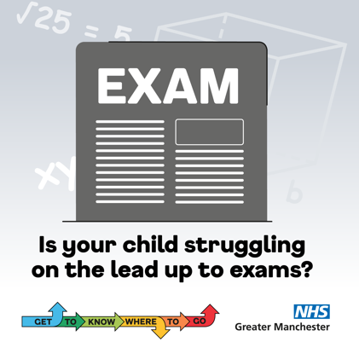 | Is your child revising for #exams and feeling overwhelmed or stressed out?  Online support is available for all students aged 10+ across Greater Manchester. Find support or chat to a mental health professional. Visit www.kooth.com or search www.gmintegratedcare.org.uk/GTKWTG  #GTKWTG #parents #stress #GM | Is your child revising for #exams and feeling overwhelmed or stressed?  Online support is available for all students aged 10+. Find support or chat to a mental health professional. Visit www.kooth.com or search www.gmintegratedcare.org.uk/GTKWTG  #GTKWTG #parents #stress #GM | Exam paper. Text underneath says ‘Is your child struggling on the lead up to exams?’  The campaign logo is in the bottom left-hand corner and the NHS logo is in the bottom right.
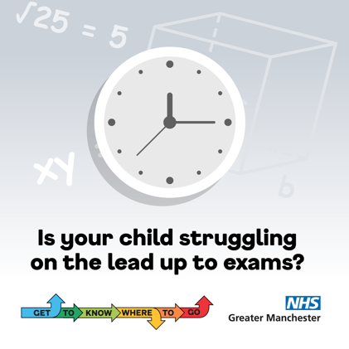 | It’s normal for young people to feel worried about exams, and that anxiety can affect young people, but also parents and carers too.  Help your child cope with exam pressure. The NHS offers great tips for ways to ease the stress www.nhs.uk/mental-health/children-and-young-adults/advice-for-parents/help-your-child-beat-exam-stress/ or search: www.gmintegratedcare.org.uk/GTKWTG  #GTKWTG #parents #stress #GM | It’s normal for young people to feel worried about exams, and that anxiety can affect not only them but also parents and carers too.  Help your child cope with exam pressure. Visit www.nhs.uk/mental-health/children-and-young-adults/advice-for-parents/help-your-child-beat-exam-stress/ or search: www.gmintegratedcare.org.uk/GTKWTG  #GTKWTG #parents #stress #GM | Clock on wall. Text underneath says ‘Is your child struggling on the lead up to exams?’  The NHS logo is in the bottom right.

