NHS Greater Manchester Communications toolkit: Get To Know Where To Go – Summer 2025

Introduction:
During the summer, many of us enjoy the longer days, warmer evenings, outdoor activities, and extra time with friends and family.
Pressures on the NHS are often associated with the winter months, but it’s important for people to take care of their health and use services wisely all year round.
Illnesses and injuries can happen at any time of year. We want to make sure people are well prepared and know where to go to get the care they need as quickly as possible.
This toolkit aligns with the Government’s new 10 Year Health Plan and it’s three major shifts in healthcare:
- Hospital to community
- Analogue to digital
- Sickness to prevention
This is reflected in the toolkit’s core themes:
- Highlight the availability and benefits of primary care and the services they provide
- Further promote the NHS App and NHS 111 online
- Raise awareness of the health risks of high temperatures and encourage action to support those who may need extra help
- Remind people the importance of vaccination ahead of overseas travel to some destinations
- Inform and educate parents/carers of children and babies under 5 in relation to common childhood illnesses and how to manage them.

How you can get involved:
The quickest and easiest way to support the campaign is to look out for the campaign assets on our social media channels and share to your followers. If you don’t already follow us, you'll find us here:
Facebook @NHSGreaterManchester
X @NHS_GM
- Instagram @nhs_gm
Or you can:
- Use the social media assets to schedule posts on your channels
- Promote the campaign using the suggested copy for your communications
- Share this toolkit with partner organisations and stakeholder lists

Newsletter/Website copy

How to stay healthy and well this summer
Summer is the perfect time for family fun, sunshine, and making memories. You can help your summer run smoothly by getting to know where to go in case of injury or illness, so you can get the help you need more quickly. Because accidents happen and little ones will always pick up bugs!
To find the right service for your needs, go to the ‘Get To Know Where To Go’ page on the NHS Greater Manchester website.
Parents and carers with children and babies under 5 can download our brand-new leaflet from the NHS Greater Manchester website for advice and tips on how to manage childhood illnesses – from the comfort of your own home.
Your summer contact list:
- Teeth: Greater Manchester Urgent Dental Service – call 0333 332 3800. 8am-10pm every day, including weekends and bank holidays.
- Eyes: Greater Manchester Urgent Eye Care Service – www.primaryeyecare.co.uk/find-a-practice. Available all week, including weekends and bank holidays.
- Mental health and wellbeing: If you find yourself feeling anxious, stressed or overwhelmed there’s a range of support that you can self-refer to tinyurl.com/resources-and-support
- Not sure what to do? Go to https://111.nhs.uk/ (over 5 years of age only) or call NHS 111.
- Food: find your local food bank – go to the 'Helping Hand - Food' page on the Greater Manchester Combined Authority website'.

Text and images for social media
To download all the available images, please visit the Campaign Resource Centre on the NHS GM website. Please do not copy and paste the images in the table below as they are lower quality.
A table including images and text for social media.
Image | Long text for social media – Facebook/Instagram | Short text for social media – X | Alt text for the image
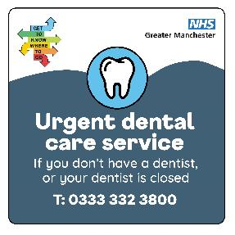 | Don’t let pain in your mouth, teeth or gums spoil the fun this summer.  If your dentist is closed or you don’t have a regular dentist, call the Greater Manchester Urgent Dental Care Service on 0333 332 3800.  Following an initial assessment, you will be offered a same day or next day appointment, given advice, or signposted to other services.  #GTKWTG #GreaterManchester #DentalCare #Dentist #Teeth | Don’t let tooth or gum pain ruin your summer!  No regular dentist, or yours is closed?  Call Greater Manchester Urgent Dental Care Service on 0333 332 3800  #GTKWTG #GreaterManchester #DentalCare #Dentist #Teeth | Visual contains image of a tooth. Text reads urgent dental care service. If you don’t have a dentist or your dentist is closed, call 0333 3323800.
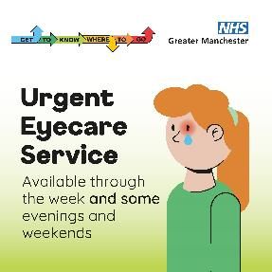 | The Greater Manchester Urgent Eyecare Service can help if you have:  - A red or painful eye  - Something in your eye that won’t come out  - Sudden change in vision  - Flashes or things floating across your eyes  Search ‘primary eyecare find a practice Greater Manchester’ to find an optician that is part of the service.  #GTKWTG #Eyecare #GreaterManchester #Optician #RedEye | Got a red or painful eye? Something stuck? Sudden vision changes or things floating across your eyes?  The Greater Manchester Urgent Eyecare Service can help.  Search ‘primary eyecare find a practice Greater Manchester.’  #GTKWTG | Visual contains image of a person with one red eye and a single tear. Text reads urgent eyecare service. Available through the week and some evenings and weekends.
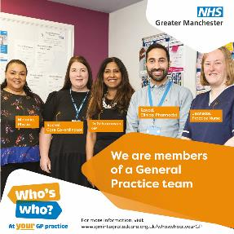 | The people who work at your GP practice team all have different roles.  Some are there to help things run smoothly, whilst others are health professionals with their own specialist skills.  You won’t always need to see a GP.  To find out more about your GP practice team search ‘who’s who at your GP practice’.  #WhosWhoAtYourGP #GP #GPpracticeTeam #GeneralPractitioner #GreaterManchester #PracticeNurse | Not everyone at your GP practice is a GP.  From admin staff to specialist health professionals, your practice team has a range of skills to support you.  Search ‘who’s who at your GP practice’ to learn more.  #WhosWhoAtYourGP | Visual contains image of a group of medical professionals standing in a GP waiting room. Text reads, we are members of a General Practice team. For more information visit www.gmintegratedcare.org.uk/whoswhoatyourgp.
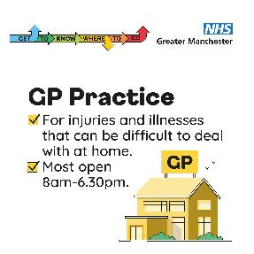 | Your GP practice can help with check-ups, treat common illnesses, give advice on staying healthy, and refer you to specialists if needed.  Most practices are open for appointments from 8am-6pm.  Phone and online appointments make it quick and easy to get the help you need.  Search ‘Get to Know Where to Go to find out more.  #GTKWTG #GreaterManchester #GPpractice #GP #GeneralPractitioner | Your GP practice can help with check-ups, common illnesses, health advice, specialist referrals and more.  Most practices are open 8am–6pm.  Search ‘Get to Know Where to Go’ to learn more.  #GTKWTG | Visual shows an image of a GP practice building. Text reads, GP practice. For injuries and illnesses that can be difficult to deal with at home. Most GP practices are open 8am-6.30pm. Get To Know Where To Go.
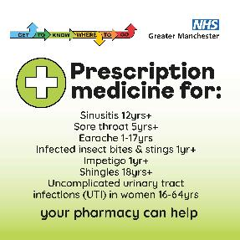 | This summer think Pharmacy First!  Your local pharmacy can provide advice and support for a range of minor illness – plus prescription medicines for some common conditions. All without a GP appointment!  Search ‘Greater Manchester Pharmacy First’ to find out more.  #GTKWTG #PharmacyFirst #SoreThroat #Earache #Pharmacy #GreaterManchester | This summer, think Pharmacy First!  Your local pharmacy can provide prescription medicines for some common conditions without a GP appointment.  Search ‘Greater Manchester Pharmacy First’ to find out more.  #GTKWTG | Visual shows image of a white cross in a green circle. Text reads, Prescription medicine for: Sinusitis 12yrs+, Sore throat 5yrs+, Earache 1-17yrs, Infected insect bites and stings 1yr+, Impetigo 1yr+, Shingles 18yrs+, Uncomplicated urinary tract infections (UTI) in women 16-64 yrs. Your pharmacy can help. Get To Know Where To Go.
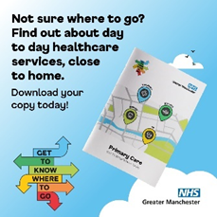 | Primary Care is the day-to-day healthcare that’s available close to where you live – GP practices, pharmacies, dentists and opticians.  Our primary care booklet tells you all you need to know about primary care health services to help you, and your family get the care you need from the right people, in the right place, at the right time.  To download it, search ‘Greater Manchester Primary Care Booklet’.  #GTKWTG #PrimaryCare #GreaterManchester #GPpractice #Dentist #Pharmacy #Optician | Our primary care booklet tells you everything you need to know about primary care health services - GPs, pharmacies, dentists and optician.  Search ‘Greater Manchester Primary Care Booklet’ to download.  #GTKWTG | Visual contains a picture of the primary care booklet in a cloudy sky. The Get To Know Where To Go logo is to the right. Text reads: Not sure where to go? Find out about day to day healthcare services, close to home. Download your copy today!
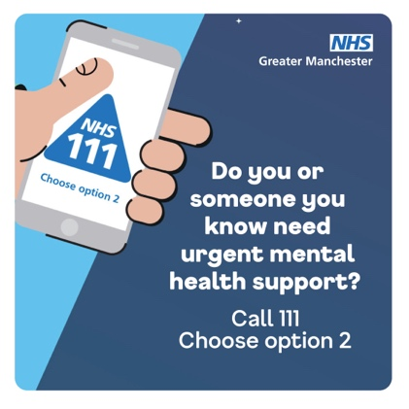 | We know the summer holidays can be a tricky time for some families, with children and young people at home and everyone out of their usual routine.  If you, or a member of your family, are in urgent need of mental health support – call NHS 111 and select option 2.  You can speak to specially trained professionals who can also direct you to other services for further support.  NHS 111 SignVideo is available for BSL users. Text relay also available 18001 111.  #GTKWTG #GreaterManchester #NHS111 #MentalHealthCrisis #MentalHealth #MentalHealthSupport | If you need urgent mental health support, call NHS 111 and press option 2.  Trained mental health professionals are there to help.  NHS 111 SignVideo is available for BSL users. Text relay also available 18001 111.  #GTKWTG | Visual is split in half. Half of the background is showing a daytime, blue and cloudy sky, the other half is a nighttime starry sky. There is a hand reaching in holding a mobile phone that has the NHS 111 logo on the screen. Text reads: Do you or someone you know need urgent mental health support? Call 111. Choose option 2.
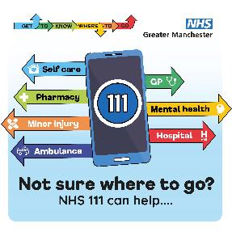 | If you need medical help and you’re not sure where to go, think NHS 111.  It’s available 24 hours a day, 7 days a week.  Call 111 for FREE (over 5 years of age).  Search ‘NHS 111’  Or use the NHS App.  NHS 111 SignVideo is available for BSL users. Text relay also available 18001 111.  #GTKWTG #NHS111 #GreaterManchester #Pharmacy #MentalHealth #GPpractice | Not sure where to get medical help?  Think NHS 111 – available 24/7.  Call 111 FREE (ages 5+)  Search ‘NHS 111’  Use the NHS App  NHS 111 SignVideo is available for BSL users. Text relay also available 18001 111.  #GTKWTG | Visual contains image of a smartphone with 111 displayed on it. Arrows are coming out of it in different colours, indicating different health services. Text reads, Self-care, Pharmacy, Minor injury, Ambulance, GP, Mental health, Hospital. Not sure where to go? NHS 111 can help… Get to know where to go.
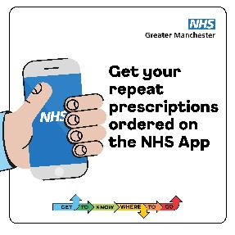 | Make more time for the important things this summer. Ordering repeat prescriptions is quicker with the NHS App.  If you’re away from home, you can choose to collect from a pharmacy nearby – wherever you are in the UK.  Search ‘NHS App’ and get it set up on your device.  #GTKWTG #GreaterManchester #NHSApp #RepeatPrescriptions #UKstaycation #HolidayPrep | Make more time for what matters this summer.  Order repeat prescriptions quickly with the NHS App.  On holiday? Choose a nearby pharmacy anywhere in the UK.  Search ‘NHS App’ to get started.  #GTKWTG #NHSApp | Visual shows a hand reaching in holding a mobile phone that has the NHS logo on the screen. Text reads: Get your repeat prescriptions ordered on the NHS App. Get to know where to go.
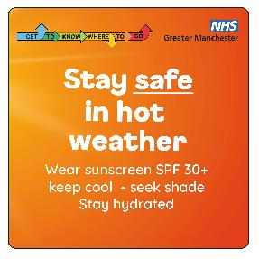 | Hot weather is coming!  Our top tips for staying safe:  - Seek out shade  - Drink lots of water  - Keep you and your home cool  For tips to beat the heat: search ‘hot weather advice’ on gov.uk.  #GTKWTG #GreaterManchester #HotWeather #HeatHealth #KeepCool #StaySafe | Hot weather’s on the way!  Stay safe with our top tips:  Find shade  Drink plenty of water  Keep yourself and your home cool  For more advice, search ‘hot weather advice’ on gov.uk.  #GTKWTG #HotWeather | Visual contains text only. Text reads, Stay safe in hot weather. Wear sunscreen SPF 30+, keep cool – seek shade. Stay hydrated.… Get to know where to go.
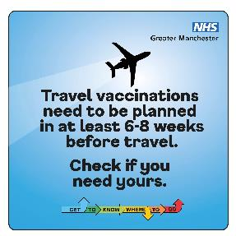 | Are you jetting off to somewhere exotic this summer? Make sure you’re fully protected for your travels.  Any vaccinations need to be planned in at least 6-8 weeks before you go. Contact your GP practice or travel clinic for more info.  #GTKWTG #GreaterManchester #TravelVaccinations #HolidayPlanning #TravelHealth #HolidayEssentials | Jetting off somewhere exotic this summer?  Make sure you’re fully protected!  Plan vaccinations 6-8 weeks before you travel.  Contact your GP practice or travel clinic for advice.  #GTKWTG | Visual contains image of an aeroplane. Text reads, Travel vaccinations need to be planned in at least 6-8 weeks before travel. Check if you need yours.
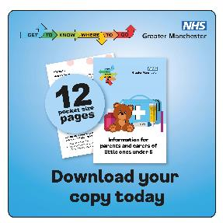 | Our new leaflet has information and advice on how to manage common illnesses in little ones under 5.  It breaks down the different symptoms, give tips on how to manage at home, and advice on when it’s time to see a healthcare professional.  Search ‘NHS GM new leaflet’ to download your copy.  #GTKWTG #GreaterManchester #ChildhoodIllness #LittleOnes #PoorlyKids #Baby  Link to put in comment - https://gmintegratedcare.org.uk/wp-content/uploads/2025/07/nhs-gm-get-to-know-where-to-go-for-parent-and-carers.pdf | Got little ones under 5? Our new leaflet helps you manage common illnesses at home.  Symptoms explained  Home care tips  When to see a healthcare professional  Search ‘NHS GM new leaflet’ to get your copy.  #GTKWTG  Link to put in comment - https://gmintegratedcare.org.uk/wp-content/uploads/2025/07/nhs-gm-get-to-know-where-to-go-for-parent-and-carers.pdf | Visual contains an image of a leaflet called 'Information for parents and carers of little ones under 5'. The cover shows a teddy bear and a first aid kit. Text reads: 12 pocket size pages. Download your copy today. Get to know where to go.
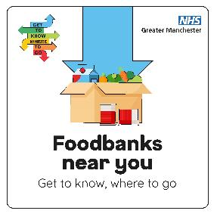 | We know the summer holidays can be tough for families – especially if you usually rely on free school meals.  Don’t go hungry - your local food bank is there to help!  There are lots of food banks across Greater Manchester, and many offer more than just food.  Search ‘Greater Manchester Food Banks’ to find your nearest.  #GTKWTG #GreaterManchester #FoodBank #Summer #HelpWithFood #Community | Summer holidays can be tough, especially if you rely on free school meals.  Your local food bank is here to help!  Many food banks in Greater Manchester offer more than just food.  Search ‘Greater Manchester Food Banks’ to find your nearest.  #GTKWTG | Visual shows a cardboard box with food and drink, an arrow is pointing to it. Text reads, Foodbanks near you. Get to know where to go.
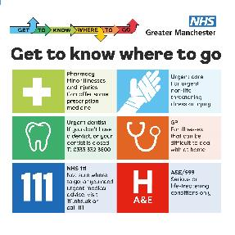 | Get to know where to go and help us save our emergency departments for those who need them the most.  #NHS111 #GreaterManchester #HealthAdvice #GTKWTG | Get to know where to go and help us save our emergency departments for those who need it most.  #NHS111 #GTKWTG | In the top left corner is the campaign logo. In the top right corner is the NHS GM logo. Informational NHS Greater Manchester poster titled 'Get to know where to go'. It features six coloured sections with icons and guidance: 1) Pharmacy – minor illnesses and injuries; 2) Urgent care – non-life-threatening issues; 3) Urgent dentist – contact 0333 332 3800 if no dentist; 4) GP – for illnesses hard to manage at home; 5) NHS 111 – for urgent advice or if unsure; 6) A&E/999 – for serious or life-threatening conditions only.

