NHS Great Manchester communications toolkit – Keep protected this winter (winter vaccinations campaign)

Introduction:
Every winter the NHS offers free vaccines, to those eligible, to protect against serious illnesses that become more common as the weather gets colder.
This year, NHS Greater Manchester is launching its ‘Keep protected this winter’ campaign. The campaign aims to tap into our natural instinct to keep ourselves and our loved ones safe and protected. We do this through little actions each day – making sure everyone has their seatbelt on, telling our children to look both ways before they cross the road, and keeping an eye on the baby monitor.
We want the public to see getting vaccinated in the same way. A simple action we can take to protect ourselves and others from serious illness.
The first phrase of the campaign and the vaccines this toolkit focuses on are:

- Flu
- RSV (Respiratory Syncytial Virus)

How you can get involved:
This toolkit includes a range of assets for you to share across your channels, display in waiting rooms and use to support conversations about vaccines with members of the public.

Please also share this toolkit with your partner organisations and stakeholder lists.

To visit the webpage for this campaign, search: NHS GM Winter vaccinations.

Assets included in this toolkit:
Leaflets – 4 different electronic leaflets with information on what vaccine are available, for who and where to get them.
Social media assets – Keep Protected social media assets aimed at pregnant people, parents of children aged 2–3 and school aged children, as well as assets for the general public.
Social media copy – For you to use alongside the social media assets provided, and signpost people to our winter vaccinations webpage.
Posters – For display in waiting rooms, community centres etc, encouraging people to get vaccinated and visit our winter vaccinations webpage for more information.
- Open belly formats – an easy document for you to edit and add your own details to, such as information on pop-up vaccinations clinics, all in the Keep Protected campaign branding.
Digital screens – Ready for you to upload on your screens in waiting rooms encouraging people to get their vaccinations this winter.
Easy Read document – explaining the winter vaccinations available, why they are important and how to get them in an easily digestible format.
FAQs sheet – for anyone who has contact with the public, to help you facilitate conversations around vaccines, dispel any myths and answer any questions.

Support the campaign on social media:

The quickest and easiest way to support the campaign is to look out for the campaign assets on our social media channels and share to your followers. If you don’t already follow us, you'll find us here:

- Facebook @NHSGreaterManchester
- Instagram @nhs_gm

Newsletter copy:
Winter is a season of fun, festivities and family times you don’t want to miss. However, as it gets colder viruses like flu and RSV can spread more easily. These viruses can lead to serious illness and even time in hospital.
Thankfully every winter the NHS offers free vaccines, to those most at risk, to keep everyone protected. That could be during pregnancy or older age or, to keep little ones, teens and those with long-term health conditions safe and well.

If you’re eligible, it’s important to get your winter vaccines each year. This helps top up your protection, even if you’ve had them before or have already been ill. That’s because your immunity fades over time, and the viruses change each year.
By getting vaccinated, you’re not only protecting yourself, but also the people you care about most.

Winter vaccinations
- Flu – can be a serious illness for people of all ages. It can lead to complications like bronchitis and pneumonia.
Adults aged over 65, pregnant people, people with long-term health conditions, people in care homes, those who live with someone with a weakened immune system and children (aged 2–3 years and school aged) are all encouraged to get the flu vaccine.

- RSV (Respiratory Syncytial Virus) - this virus causes coughs and colds and can be dangerous for older people and young babies.
Adults aged 75 to 79 and pregnant people from 28 weeks should get this vaccine. It helps protect the baby in the first few months.
- COVID-19 – can cause serious illness for some including breathing difficulties and long-lasting health problems.
Adults aged 75, people in care homes and those with a weakened immune system are encouraged to get their COVID-19 vaccine.
Keep protected this winter. To find out more about winter vaccines, including where to get them, head to the NHS Greater Manchester website, or search: NHS GM Winter vaccinations.

Social media and toolkit assets:
To download all the available images, please visit the Campaign Resource Centre on the NHS GM website. Please do not copy and paste the images in the table below as they are lower quality.

You may wish to include the link to the winter vaccinations Keep Protected webpage. Remember, it’s better to add the link in the first comment of a Facebook post as it can lower levels of engagement if it is part of the post itself.

Please note, the social media images provided are not to be used separately, but part of a carousel-style post as shown in the table below.
Asset | Facebook copy | Instagram copy | X copy | Alt text
Pregnancy  Keep loving every stage  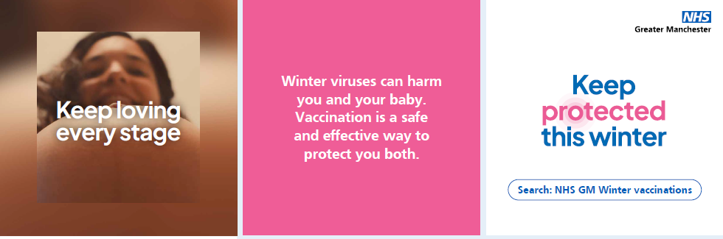 | There are a few different vaccines you can get to keep you and your baby safe while you’re pregnant.  To find out more:  - Search ‘NHS GM Winter vaccinations’  - Contact your maternity team  - Visit our website gmintegratedcare.org.uk/winter-vaccinations  #KeepProtected #Pregnant #PregnancyVaccines #HealthyPregnancy #Winter #GreaterManchester | Keep you and your baby protected this winter.  There are different vaccines you can get during pregnancy to make sure you are both safe.  Want to learn more? Search: NHS GM Winter vaccinations or contact your maternity team.  #KeepProtected #Pregnant #PregnancyVaccines #HealthyPregnancy #Winter #GreaterManchester | Protect yourself and your baby this winter. There are several vaccines recommended during pregnancy to keep you both safe.  For more info visit gmintegratedcare.org.uk/winter-vaccinations contact your maternity team.  #KeepProtected | Image 1: Pregnant person with brown hair is peering over their baby bump, looking down into the camera. Text across image: ‘Keep loving every stage’  Image 2: White text on pink background: ‘Winter viruses can harm you and your baby. Vaccination is a safe and effective way to protect you both.’  Image 3: ‘Keep protected this winter’ logo is central.  NHS GM logo in the top right corner.  Text at the bottom: ‘Search NHS GM Winter vaccinations’
Pregnancy  Keep on feeling good  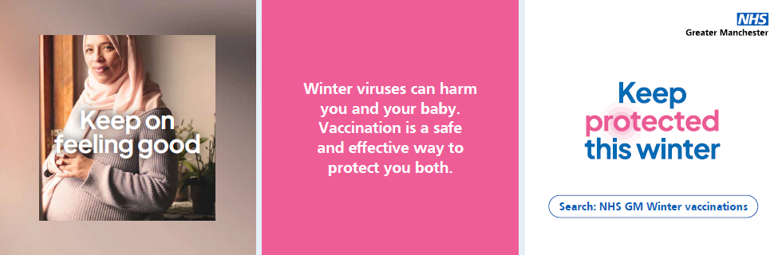 | The flu vaccine is safe at any stage of your pregnancy. The whooping cough (pertussis) vaccine is recommended from 16 weeks, and the RSV vaccine, given after 28 weeks, helps protect your baby from breathing problems after birth.  To find out more:  - Search ‘NHS GM Winter vaccinations’  - Contact your maternity team  - Visit our website gmintegratedcare.org.uk/winter-vaccinations  #KeepProtected #Pregnant #PregnancyVaccines #HealthyPregnancy #Winter #GreaterManchester | Keep you and your baby protected this winter by getting the vaccines you need while pregnant.  Find out which vaccines to have and when during your pregnancy, search: NHS GM Winter vaccinations or contact your maternity team.  #KeepProtected #Pregnant #PregnancyVaccines #HealthyPregnancy #Winter #GreaterManchester | Keep you and your baby protected this winter. The flu vaccine is safe at any stage of pregnancy. Whooping cough vaccine is recommended from 16 weeks, and RSV vaccine after 28 weeks.  For more info visit gmintegratedcare.org.uk/winter-vaccinations or contact your maternity team.  #KeepProtected | Image 1: Pregnant person wearing headscarf with hands over baby bump is looking into the camera. Text across image: ‘Keep on feeling good’  Image 2: White text on pink background: ‘Winter viruses can harm you and your baby. Vaccination is a safe and effective way to protect you both.’  Image 3: ‘Keep protected this winter’ logo is central.  NHS GM logo in the top right corner.  Text at the bottom: ‘Search NHS GM Winter vaccinations’
Pregnancy  Keep the joy going  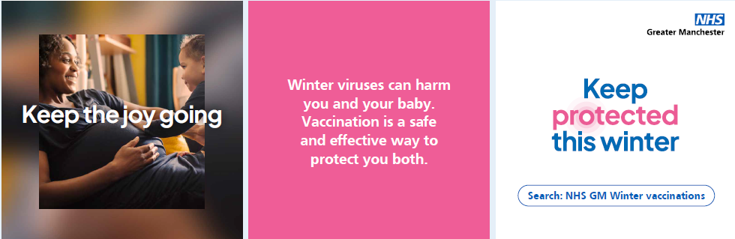 | The NHS offers free vaccinations including flu, RSV and whooping cough, to keep you and your baby safe.  To find out more:  - Search ‘NHS GM Winter vaccinations’  - Contact your maternity team  - Visit our website gmintegratedcare.org.uk/winter-vaccinations  #KeepProtected #Pregnant #PregnancyVaccines #HealthyPregnancy #Winter #GreaterManchester | Keep protected this winter. Free NHS vaccines like flu, RSV, and whooping cough help keep you and your baby safe during pregnancy.  Search: NHS GM Winter vaccinations or contact your maternity team to learn more.  #KeepProtected #Pregnant #PregnancyVaccines #HealthyPregnancy #Winter #GreaterManchester | Keep protected this winter. The NHS offers free flu, RSV, and whooping cough vaccines to help keep you and your baby safe during pregnancy.  For more info visit gmintegratedcare.org.uk/winter-vaccinations or contact your maternity team.  #KeepProtected | Image 1: Pregnant person is sat down smiling with a small child giving them a hug. Text across image: ‘Keep the joy going’  Image 2: White text on pink background: ‘Winter viruses can harm you and your baby. Vaccination is a safe and effective way to protect you both.’  Image 3: ‘Keep protected this winter’ logo is central.  NHS GM logo in the top right corner.  Text at the bottom: ‘Search NHS GM Winter vaccinations’
2-3yrs  Keep them learning  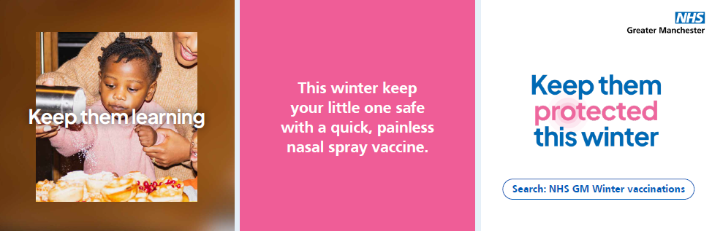 | This winter, protect your little one from flu. A quick, painless nasal spray vaccine keeps them healthy and stops flu from spreading.  If your child is aged 2-3, find out more by:  - Searching ‘NHS GM winter vaccinations’  - Contacting your GP practice  - Visit gmintegratedcare.org.uk/winter-vaccinations  #KeepProtected #Children #ChildhoodVaccines #WinterVaccines #GreaterManchester #Winter | Protect your little one from flu this winter with a quick, painless nasal spray.  If they’re aged 2–3, contact your GP practice or search NHS GM Winter vaccinations.  #KeepProtected #Children #ChildhoodVaccines #WinterVaccines #GreaterManchester #Winter | This winter, protect your child from flu with a quick, painless nasal spray vaccine.  If they’re aged 2-3, contact your GP practice or visit gmintegratedcare.org.uk/winter-vaccinations  #KeepProtected | Image 1: A toddler is sat in front of a cake. An adult is behind them helping them sprinkle sugar over the top. Text across image: ‘Keep them learning’  Image 2: White text on pink background: ‘This winter keep your little one safe with a quick, painless nasal spray vaccine.’  Image 3: ‘Keep them protected this winter’ logo is central.  NHS GM logo in the top right corner.  Text at the bottom: ‘Search NHS GM Winter vaccinations’
2-3yrs  Keep them smiling  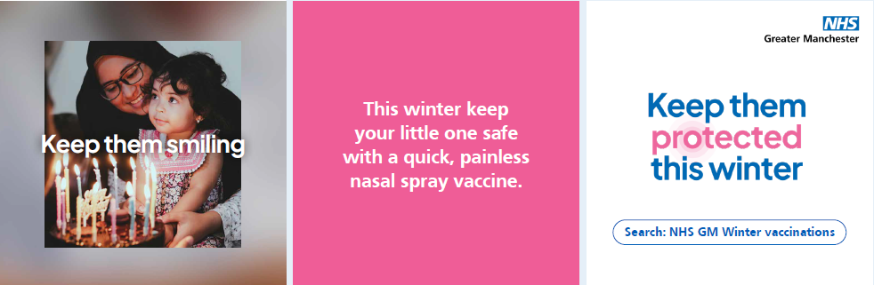 | Flu viruses change every year, so it’s really important to keep your child, and those around them, protected.  If your child is aged 2-3, find out more by:  - Searching NHS GM winter vaccinations  - Contact your GP practice  - Visit gmintegratedcare.org.uk/winter-vaccinations  #KeepProtected #Children #ChildhoodVaccines #WinterVaccines #Winter #GreaterManchester | The flu virus changes every year, so it’s important to protect your child and those around them. A quick nasal spray can make all the difference.  If your child is 2–3, contact your GP practice or search NHS GM Winter vaccinations.  #KeepProtected #Children #ChildhoodVaccines #WinterVaccines #Winter #GreaterManchester | Flu viruses change every year, so it’s important to keep your child and those around them protected. If your child is 2-3, contact your GP practice for an appointment, or visit gmintegratedcare.org.uk/winter-vaccinations  #KeepProtected | Image 1: A toddler is sat on an adult’s lap in front of a cake with birthday candles on top. The toddler is looking off camera and smiling. Text across image: ‘Keep them smiling’  Image 2: White text on pink background: ‘This winter keep your little one safe with a quick, painless nasal spray vaccine.’  Image 3: ‘Keep them protected this winter’ logo is central.  NHS GM logo in the top right corner.  Text at the bottom: ‘Search NHS GM Winter vaccinations’
2-3yrs  Keep them growing  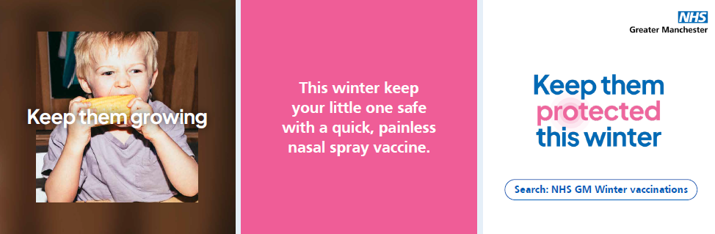 | Keeping your little one vaccinated against flu helps protect them from more serious complications like bronchitis and pneumonia.  If your child is aged 2-3, find out more by:  - Searching NHS GM winter vaccinations  - Contacting your GP practice  - Visit gmintegratedcare.org.uk/winter-vaccinations  #KeepProtected #Children #ChildhoodVaccines #WinterVaccines #Winter #GreaterManchester | Keeping your little one vaccinated against flu helps protect them from serious complications like bronchitis and pneumonia.  If your child is aged 2-3, contact your GP practice to book an appointment or search NHS GM Winter vaccinations for more information.  #KeepProtected #Children #ChildhoodVaccines #WinterVaccines #GreaterManchester #Winter | Vaccinating your little one against flu helps protect them from serious complications like bronchitis and pneumonia.  If your child is 2-3, contact your GP practice to book an appointment or visit gmintegratedcare.org.uk/winter-vaccinations  #KeepProtected | Image 1: A toddler has a piece of sweetcorn in their hand, mid-bite. Text across image: ‘Keep them growing’  Image 2: White text on pink background: ‘This winter keep your little one safe with a quick, painless nasal spray vaccine.’  Image 3: ‘Keep them protected this winter’ logo is central.  NHS GM logo in the top right corner.  Text at the bottom: ‘Search NHS GM Winter vaccinations’
School age  Keep them active  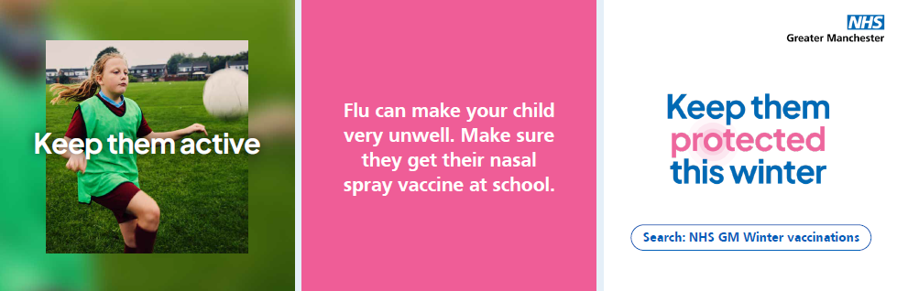 | This winter, protect your child with the flu vaccine. A quick, painless nasal spray keeps them healthy and stops flu from spreading – look out for the consent form from school.  Find out more by:  - Searching NHS GM winter vaccinations  - Visit gmintegratedcare.org.uk/winter-vaccinations  #KeepProtected #Children #SchoolVaccines #WinterVaccines #ChildhoodVaccines #Winter #GreaterManchester | Protect your child this winter with the quick, painless flu nasal spray. It keeps them healthy and stops flu spreading.  Watch out for the consent form from school!  Search NHS GM Winter vaccinations for more info.  #KeepProtected #Children #SchoolVaccines #WinterVaccines #ChildhoodVaccines #Winter #GreaterManchester | This winter, protect your child with the flu nasal spray vaccine. It’s quick, painless, and helps stop flu spreading.  Don’t forget to look out for the consent form from school.  Visit gmintegratedcare.org.uk/winter-vaccinations for more information  #KeepProtected | Image 1: A young person is wearing a green bib and sports kit. They are in a field kicking a ball. Text across the image: ‘Keep them active’  Image 2: White text on pink background: ‘Flu can make your child very unwell. Make sure they get their nasal spray at school.’  Image 3: ‘Keep them protected this winter’ logo is central.  NHS GM logo in the top right corner.  Text at the bottom: ‘Search NHS GM Winter vaccinations’
School age  Keep them strong  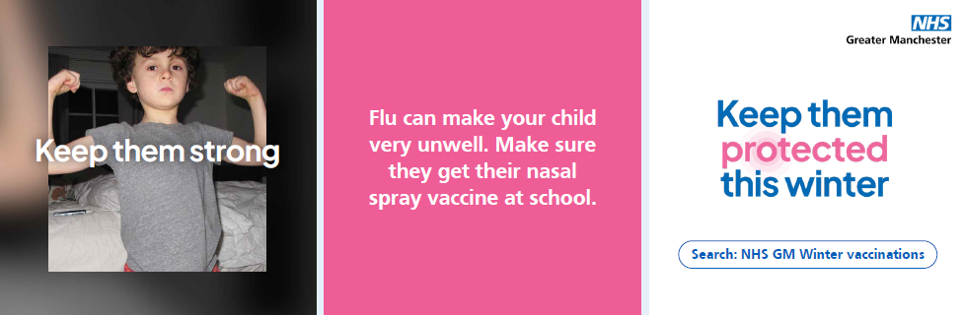 | Flu viruses change every year so it’s really important to keep your child and those around them protected.  Look out for the consent form from school.  Find out more by:  - Searching NHS GM winter vaccinations  - Visit gmintegratedcare.org.uk/winter-vaccinations  #KeepProtected #Children #SchoolVaccines #WinterVaccines #ChildhoodVaccines #Winter #GreaterManchester | Flu changes every year, so it’s important to keep your child protected. The nasal spray vaccine helps keep them—and others—safe.  Look out for the consent form from school or search NHS GM Winter vaccinations to learn more.  #KeepProtected #Children #SchoolVaccines #WinterVaccines #ChildhoodVaccines #Winter #GreaterManchester | Flu changes every year, so keep your child and those around them protected.  Look for the consent form from school or visit gmintegratedcare.org.uk/winter-vaccinations  #KeepProtected | Image 1: A young person wearing a grey t-shirt is holding both their arms up, flexing their muscles. Text across image: ‘Keep them strong’  Image 2: White text on pink background: ‘Flu can make your child very unwell. Make sure they get their nasal spray at school.’  Image 3: ‘Keep them protected this winter’ logo is central.  NHS GM logo in the top right corner.  Text at the bottom: ‘Search NHS GM Winter vaccinations’
School age  Keep them laughing  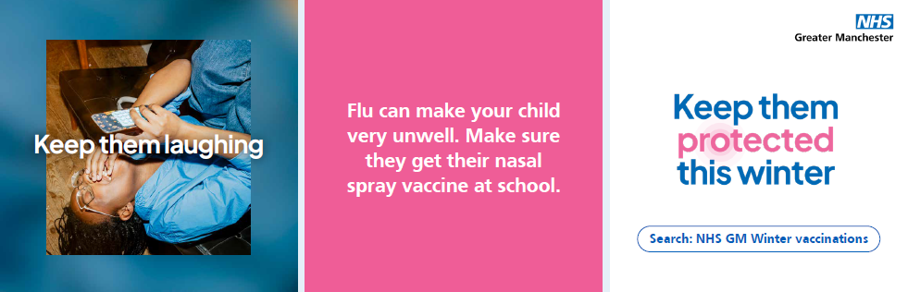 | Keeping your child vaccinated against flu helps not only protect them, but those around them. Look out for the consent form from school.  Find out more by:  - Searching NHS GM winter vaccinations  - Visit gmintegratedcare.org.uk/winter-vaccinations  #KeepProtected #Children #SchoolVaccines #WinterVaccines #ChildhoodVaccines #Winter #GreaterManchester | Flu vaccines protect your child and those around them.  Look out for the consent form from school and search NHS GM Winter vaccinations to find out more.  #KeepProtected #Children #SchoolVaccines #WinterVaccines #ChildhoodVaccines #Winter #GreaterManchester | Getting your child vaccinated against flu helps protect them and those around them from serious illness.  Look out for the consent form from school or visit gmintegratedcare.org.uk/winter-vaccinations  #KeepProtected | Image 1: A young person is hanging head first off a chair, looking at their phone in their hand. They have their hand across their mouth laughing. Text across the image: ‘Keep them laughing’  Image 2: White text on pink background: ‘Flu can make your child very unwell. Make sure they get their nasal spray at school.’  Image 3: ‘Keep them protected this winter’ logo is central.  NHS GM logo in the top right corner.  Text at the bottom: ‘Search NHS GM Winter vaccinations’
Generic  Keep going strong  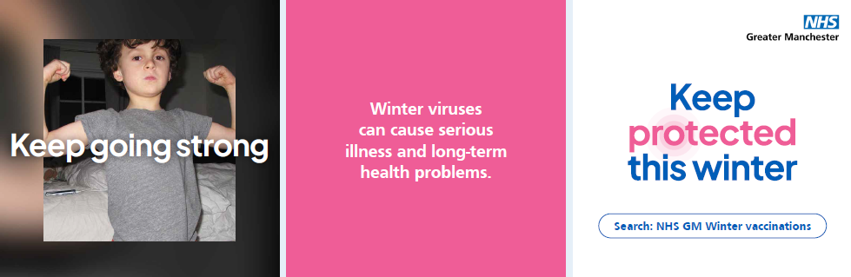 | Winter viruses can be more serious than you think, especially for vulnerable people.  Getting vaccinated is the best way to protect yourself and those around you.  Search NHS GM Winter vaccinations or visit gmintegratedcare.org.uk/winter-vaccinations to find out which vaccinations you and your family are able to get.  #KeepProtected #Greater Manchester #Winter #HealthyFamilies #WinterVaccines | Winter viruses don’t just mean a few days in bed — they can be serious, especially for vulnerable people.  Keep yourself and those around you protected.  Find out which vaccinations you and your family can get, search NHS GM Winter vaccinations.  #KeepProtected #Greater Manchester #Winter #HealthyFamilies #WinterVaccines | Winter viruses can be more serious than you think.  Vaccines help protect you and those most at risk.  Visit gmintegratedcare.org.uk/winter-vaccinations to find out which vaccines you and your family can get.  #KeepProtected | Image 1: A young person wearing a grey t-shirt is holding both their arms up, flexing their muscles. Text across image: ‘Keep going strong’  Image 2: White text on pink background: ‘Winter viruses can cause serious illness. Find out which vaccines you and your family can get.’  Image 3: ‘Keep protected this winter’ logo is central.  NHS GM logo in the top right corner.  Text at the bottom: ‘Search NHS GM Winter vaccinations’
Generic  Keep well all winter  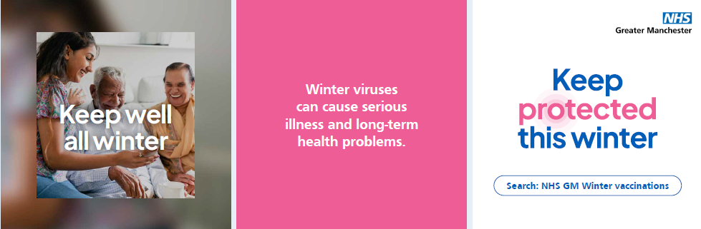 | Winter viruses can lead to serious illness and lasting health issues for some people. Getting vaccinated is the best way to keep everyone protected.  Search NHS GM Winter vaccinations or visit gmintegratedcare.org.uk/winter-vaccinations to check which vaccinations you and your family are able to get.  #KeepProtected #GreaterManchester #HealthyFamilies #WinterVaccines #Winter | Winter viruses can cause serious illness, especially for some people. Getting vaccinated is the best way to protect yourself and your family.  Search NHS GM Winter vaccinations to see which vaccines are available for you and your family.  #KeepProtected #GreaterManchester #HealthyFamilies #WinterVaccines #Winter | Winter viruses can cause serious illness. Vaccination is the best way to protect you and your family.  Visit gmintegratedcare.org.uk/winter-vaccinations to find out more.  #KeepProtected | Image 1: Three people are sat together on a sofa. One is young, and the other too are elderly. They are laughing together. Text across the image: ‘Keep well all winter’  Image 2: White text on pink background: ‘Winter viruses can cause serious illness. Find out which vaccines you and your family can get.’  Image 3: ‘Keep protected this winter’ logo is central.  NHS GM logo in the top right corner.  Text at the bottom: ‘Search NHS GM Winter vaccinations’
Generic  Keep living your best life  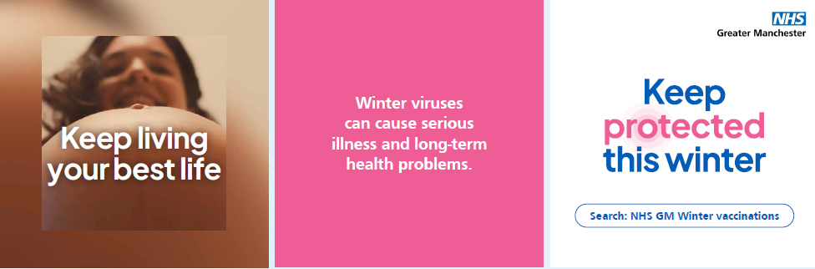 | Flu and RSV can lead to long-term complications and even hospital care.  Search NHS GM Winter vaccinations or visit gmintegratedcare.org.uk/winter-vaccinations to check which vaccinations you and your family may be able to get.  #KeepProtected #GreaterManchester #HealthyFamilies #WinterVaccines #Winter | Flu and RSV can cause serious complications and even lead to hospital stays. Keep your family protected this winter.  Search NHS GM Winter vaccinations to find out which vaccines you and your family are eligible for.  #KeepProtected #GreaterManchester #HealthyFamilies #WinterVaccines #Winter | Flu and RSV can cause serious complications and hospital stays. Protect your family this winter.  Visit gmintegratedcare.org.uk/winter-vaccinations to learn more.  #KeepProtected | Image 1: Image 1: Pregnant person with brown hair is peering over their baby bump, looking down into the camera. Text across image: ‘Keep living your best life’  Image 2: White text on pink background: ‘Winter viruses can cause serious illness. Find out which vaccines you and your family can get.’  Image 3: ‘Keep protected this winter’ logo is central.  NHS GM logo in the top right corner.  Text at the bottom: ‘Search NHS GM Winter vaccinations’

