NHS Great Manchester communications toolkit – Keep protected this winter (October)

Introduction

Starting in October, the NHS will offer COVID-19 and flu vaccinations to those most at risk of becoming seriously ill as colder weather approaches. This next phase of the programme focuses on older adults (aged 65 and over, including those aged 75+) and individuals with long-term health conditions.
To support uptake among these groups, we’ve added new assets to our campaign resource including a range of assets in accessible formats and different languages such as videos and translated leaflets. These complement existing resources designed to encourage winter vaccinations for other priority cohorts, including pregnant women, children aged 2–3, and school-aged children.

How you can get involved
This toolkit includes a range of assets for you to share across your channels, display in waiting rooms and help reach different communities across Greater Manchester.
Please also share this toolkit with your partner organisations and stakeholder lists.
To visit the webpage for this campaign, search: NHS GM Winter vaccinations.

Assets included in this toolkit
- Leaflet in different languages – a leaflet with information on what vaccines are available, for who and where to get them in Arabic, Urdu, French and Chinese.
- Easy Read document – explaining the winter vaccinations available, why they are important and how to get them in an easily digestible format.
- Videos in different languages – providing information on winter vaccines from clinicians in Arabic, Bengali, Mandarin, Hindi, Punjabi, Romanian, Russian and Spanish.
- Social media assets (new single image format) – Keep Protected social media assets aimed at people aged 65+ and 75+ as well as those with long-term health conditions.
- Social media copy – For you to use alongside the social media assets provided, and signpost people to our winter vaccinations webpage.
- Posters – For display in waiting rooms, community centres etc, encouraging people to get vaccinated and visit our winter vaccinations webpage for more information.
- Digital screens – Ready for you to upload on your screens in waiting rooms encouraging people to get their vaccinations this winter.

Support the campaign on social media
The quickest and easiest way to support the campaign is to look out for the campaign assets on our social media channels and share to your followers. If you don’t already follow us, you'll find us here:
- Facebook @NHSGreaterManchester
- Instagram @nhs_gm
Newsletter copy

There’s no denying it – winter is on its way! As well as more time with family and friends, colder weather also means more viruses spreading around.
As you get older, or if you live with a long-term health condition, viruses which pass more easily from person to person during the winter months, such as flu and COVID-19, can lead to serious illness and even time in hospital.
That’s why the NHS offers free winter vaccines to those most at risk. These vaccines keep you protected and going strong this winter.
Keep protected this winter. To find out more about winter vaccines, including where to get them, head to the NHS Greater Manchester website, or search: NHS GM Winter vaccinations.
What vaccines you’re eligible for and where to get them
If you’re eligible, it’s important to get your winter vaccines each year. This helps top up your protection, even if you’ve had them before or have already been ill. That’s because your immunity fades over time, and the viruses change each year.
Aged 65 and over
You are eligible for:
- Flu vaccine – you can get vaccinated at your GP practice or local pharmacy.
Aged 75 and over (including those who will be 75 by January 2026)
You are eligible for:
- COVID-19 vaccine – you can get vaccinated at your GP practice, local pharmacy, walk-in vaccination site or your care home (if you live in a care home).
- Flu vaccine – you can get vaccinated at your GP practice, local pharmacy, or your care home (if you live in a care home for older adults).
Aged 75-79 (and who turned 80 after 1 September 2024)
You are also eligible for:
- RSV – you can get vaccinated at your GP practice. You only get the RSV vaccine once, unlike the flu and COVID-19 vaccine.
People with a long-term health condition
This includes people with a lung or heart condition, kidney or liver disease, diabetes or a learning disability. Find a full list on the NHS website (www.nhs.uk/vaccinations/flu-vaccine)
You are eligible for:
- Flu vaccine – you can get vaccinated at your GP practice or local pharmacy.
People who are immunosuppressed
This includes people who have a weakened immune system due to a health condition or treatment. Find a full list on the NHS website (www.nhs.uk/vaccinations/covid-19-vaccine)
You are eligible for:
- COVID-19 vaccine – you can get vaccinated at your GP practice, local pharmacy or at a walk-in vaccination site.
Pregnant people, children aged 2–3 and school aged children are also eligible for winter vaccinations, find out more information on NHS Greater Manchester website, or search: NHS GM Winter vaccinations.

Social media and toolkit assets
To download all the available images, please visit the Campaign Resource Centre on the NHS GM website. Please do not copy and paste the images in the table below as they are lower quality. See social media paper as follows.
Asset | Facebook copy | Instagram copy | X | Alt text
Keep living fully  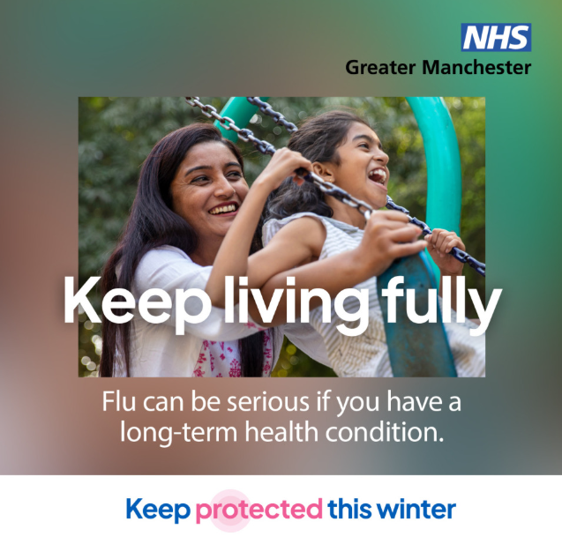 | Winter viruses can be serious if you have a long-term health  condition. If you’re at higher risk, getting vaccinated will help keep you safe.  You can book your vaccines with your GP practice.  For more information visit  www.gmintegratedcare.org.uk/winter-vaccinations/people-with health-issues  #KeepProtected #GreaterManchester #WinterVaccines #LongTermConditions #Winter | Winter viruses can be more serious if you have a long-term health condition.  Getting vaccinated is a simple way to stay protected this winter.  Book your vaccines with your GP practice.  Search: GM Winter vaccinations for more info.  #KeepProtected #GreaterManchester #WinterVaccines #LongTermConditions #Winter | Winter viruses can be serious if you have a long-term health condition.  Keep protected —book your vaccines with your GP practice.  For more info visit www.gmintegratedcare.org.uk/winter-vaccinations/people-with health-issues  #KeepProtected | Person with black hair is pushing a young child on the swings.  Text across the image: Keep living fully  Text underneath: Flu can be serious if you have a long-term health condition.  NHS GM logo in the top right-hand corner.  Keep protected campaign logo is at the bottom.
Keep going strong  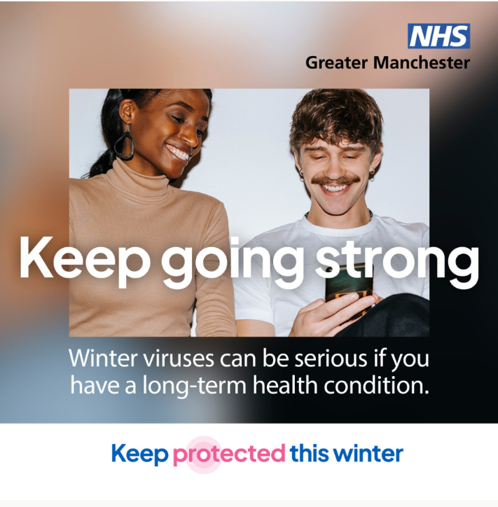 | If you have a long-term health condition, you’re more at risk of getting seriously ill from flu. Keep protected with the vaccine.  Book an appointment with your GP practice or local pharmacy.  For more information visit  www.gmintegratedcare.org.uk/winter-vaccinations/people-with health-issues  #KeepProtected #GreaterManchester #WinterVaccines #LongTermConditions #Winter | If you have a long-term health condition, you’re more at risk of serious illness from flu.  Protect yourself by getting the flu vaccine this season.  Book your appointment with your GP practice today.  Search: GM Winter vaccinations for more info.  #KeepProtected #GreaterManchester #WinterVaccines #LongTermConditions #Winter | If you have a long-term health condition, flu can be serious.  Keep protected by getting the flu vaccine at your GP practice.  For more information visit  www.gmintegratedcare.org.uk/winter-vaccinations/people-with health-issues  #KeepProtected | Two people are sat together. One has black hair and wearing a long-sleeve top and jeans, the other has a moustache and wearing a white t-shirt and has a phone in their hand. They are both looking at the phone and laughing.  Text across the image: Keep going strong  Text underneath: Winter viruses can be serious if you have a long-term health condition.  NHS GM logo in the top right-hand corner.  Keep protected campaign logo is at the bottom.
Keep doing what you love  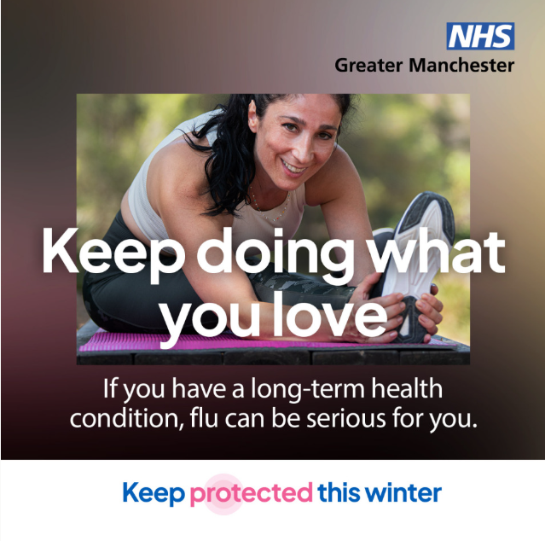 | Flu can be serious if you have a long-term health condition. Keep protected by having your safe and effective flu vaccination.  Book your appointment with your GP practice or local pharmacy today.  For more information visit  www.gmintegratedcare.org.uk/winter-vaccinations/people-with health-issues  #KeepProtected #GreaterManchester #WinterVaccines #LongTermConditions #Winter | Flu can be serious if you have a long-term health condition.  Keep protected this winter with a safe and effective flu vaccine.  Book your appointment with your GP practice today.  Search: GM Winter vaccinations for more info.  #KeepProtected #GreaterManchester #WinterVaccines #LongTermConditions #Winter | Flu can be serious if you have a long-term health condition. Stay protected by having your safe and effective flu vaccination.  Book your appointment with your GP practice today.  For more information visit  www.gmintegratedcare.org.uk/winter-vaccinations/people-with health-issues  #KeepProtected | Person with black hair in a ponytail is wearing activewear and stretching as they smile into the camera.  Text across the image: Keep doing what you love.  Text underneath: If you have a long-term health condition, flu can be serious for you.  NHS GM logo in the top right-hand corner.  Keep protected campaign logo is at the bottom.
Keep living your best life  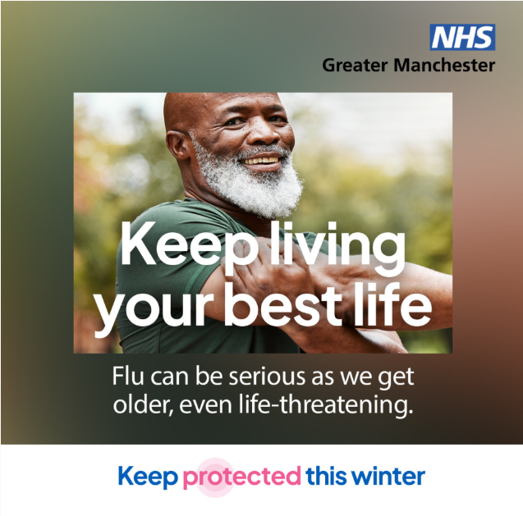 | Flu can be serious as you get older, even life-threatening. If you’re over 65, your yearly flu vaccine helps protect you.  You can get your vaccine at your GP practice or local pharmacy.  For more information visit www.gmintegratedcare.org.uk/winter-vaccinations/older-people  #KeepProtected #GreaterManchester #WinterVaccines #Over65s  #Winter | Flu can be serious as you get older — even life-threatening.  If you're 65 or over, your yearly flu vaccine helps protect you.  Get it at your GP practice or local pharmacy.  Search: NHS GM Winter vaccinations for more info.  #KeepProtected #GreaterManchester #WinterVaccines #Over65s  #Winter | Flu can be serious as you get older. If you're 65+, your yearly flu vaccine helps protect you.  Get it at your GP practice or local pharmacy.  For more information visit www.gmintegratedcare.org.uk/winter-vaccinations/older-people  #KeepProtected | Person with a short grey beard is looking directly into the camera while smiling. They are stretching out their arm.  Text across the image: Keep living your best life  Text underneath: Flu can be serious as we get older, even life-threatening.  NHS GM logo in the top right-hand corner.  Keep protected campaign logo is at the bottom.
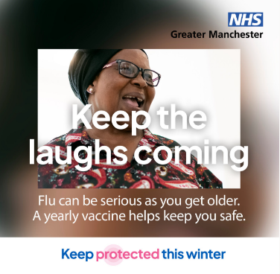  Keep the laughs coming | The flu virus changes every year. If you’re over 65, even if you had the vaccine last year, you need to get it again to keep protected. Contact your GP practice or local pharmacy.  For more information visit www.gmintegratedcare.org.uk/winter-vaccinations/older-people  #KeepProtected #GreaterManchester #WinterVaccines #Over65s  #Winter | The flu virus changes every year. If you’re over 65, it’s important to get your vaccine again this winter to keep protected — even if you had it last year.  Get your flu vaccine at your GP practice or local pharmacy.  Search: NHS GM Winter vaccinations for more info.  #KeepProtected #GreaterManchester #WinterVaccines #Over65s  #Winter | The flu changes every year. If you’re over 65, make sure you get your vaccine again to keep protected.  Contact your GP practice or local pharmacy.  For more information visit www.gmintegratedcare.org.uk/winter-vaccinations/older-people  #KeepProtected | Person wearing glasses and a patterned blouse is laughing at something off camera.  Text across the image: Keep the laughs coming  Text underneath: Flu can be serious as you get older. A yearly vaccine helps keep you safe.  NHS GM logo in the top right-hand corner.  Keep protected campaign logo is at the bottom.
Keep enjoying the little things  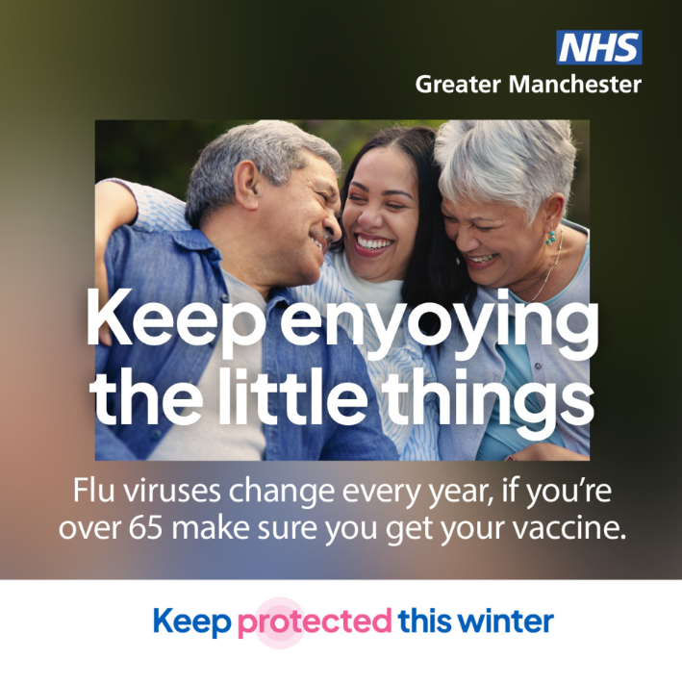 | Flu can be serious as we get older. That’s why the flu vaccine is recommended every year. It’s safe, effective, and helps protect those most at risk.  Contact your GP practice or local pharmacy.  For more information visit www.gmintegratedcare.org.uk/winter-vaccinations/older-people  #KeepProtected #GreaterManchester #WinterVaccines #Over65s  #Winter | Flu can be serious as we get older — that’s why the flu vaccine is recommended every year. It’s safe, effective, and protects those most at risk.  Don’t wait! Contact your GP practice or local pharmacy to book your vaccine and keep protected this winter.  Search: NHS GM Winter vaccinations for more info.  #KeepProtected #GreaterManchester #WinterVaccines #Over65s  #Winter | Flu can be serious as we get older. Get your safe, effective vaccine to keep protected this winter.  Contact your GP practice or local pharmacy.  For more information visit www.gmintegratedcare.org.uk/winter-vaccinations/older-people  #KeepProtected | Three people are sat as a group and laughing with each other. One has short grey hair and wearing a blue shirt, the person in the middle has on a white top and long brunette hair and the last person has short grey hair and a light blue cardigan.  Text across the image: Keep enjoying the little things  Text underneath: Flu viruses change every year, if you’re over 65 make sure you get your vaccine.  NHS GM logo in the top right-hand corner.  Keep protected campaign logo is at the bottom.
Keep the winter cheer going  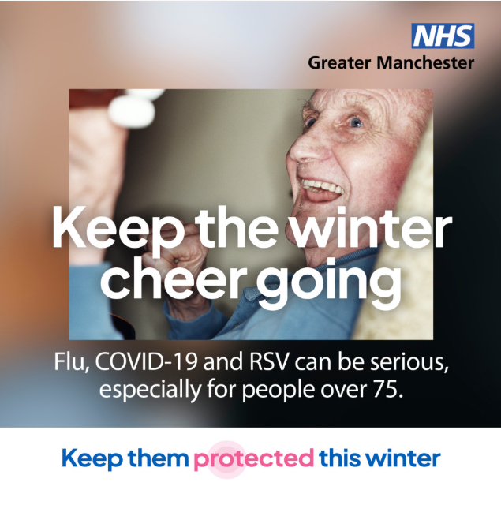 | Winter viruses can be serious as we get older. If someone you know is over 75, remind them to get the vaccines they’re eligible for.  They can book their vaccines with their GP practice or local pharmacy.  For more information visit www.gmintegratedcare.org.uk/winter-vaccinations/older-people  #KeepProtected #GreaterManchester #WinterVaccines #Over75s #Winter | Know someone aged 75 or over? Remind them to keep protected this winter.  Winter viruses can have a serious impact as we age — vaccines make a real difference.  They can book their vaccines with their GP practice.  Search: NHS GM Winter vaccinations for more info.  #KeepProtected #GreaterManchester #WinterVaccines #Over75s #Winter | Know someone aged 75 or over? Remind them to keep protected this winter by booking their vaccines with their GP practice.  For more information visit www.gmintegratedcare.org.uk/winter-vaccinations/older-people  #KeepProtected | An older person is sat in a chair smiling while they are playing a guitar.  Text across the image: Keep the winter cheer going  Text underneath: Flu, COVID-19 and RSV can be serious, especially for people over 75.  NHS GM logo in the top right-hand corner.  Keep protected campaign logo is at the bottom.
Keep your routine going  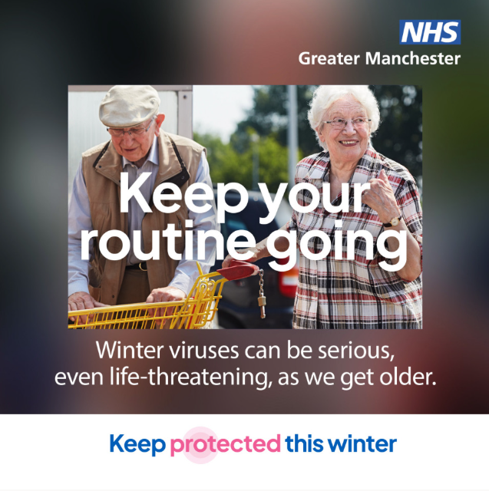 | Winter viruses can be serious as we get older. If you're over 75, make sure you get the vaccines you're eligible for.  You can book your vaccines with your GP practice.  For more information visit www.gmintegratedcare.org.uk/winter-vaccinations/older-people  #KeepProtected #GreaterManchester #WinterVaccines #Over75s #Winter | Winter viruses can be serious as we get older. If you’re 75 or over, don’t forget to get the vaccines you’re eligible for!  Booking is easy — just contact your GP practice.  Want to learn more? Search: NHS GM Winter vaccinations  #KeepProtected #GreaterManchester #WinterVaccines #Over75s #Winter | Winter viruses be serious as we age. If you’re 75+, get your vaccines!  Book via your GP practice.  For more information visit www.gmintegratedcare.org.uk/winter-vaccinations/older-people  #KeepProtected | Two older people are in a car park pushing a supermarket trolley. One is wearing flat cap and looking down at the ground. The other is smiling and wearing glasses and a patterned blouse.  Text across the image: Keep your routine going  Text underneath: Winter viruses can be serious, even life-threatening, as we get older.  NHS GM logo in the top right-hand corner.  Keep protected campaign logo is at the bottom.
Keep making memories  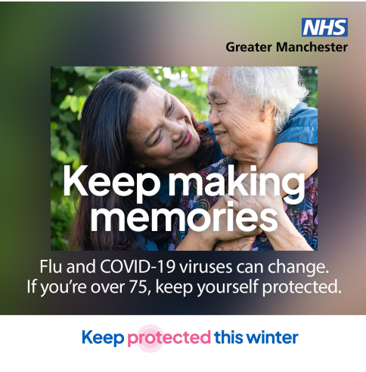 | Flu and COVID-19 viruses can change each year. Even if you’ve been vaccinated before, if you’re over 75, you need to get your vaccines again to keep protected.  Book your appointments with your GP practice today.  For more information visit www.gmintegratedcare.org.uk/winter-vaccinations/older-people  #KeepProtected #GreaterManchester #WinterVaccines #Over75s #Winter | Flu and COVID-19 viruses can change every year. Even if you’ve had the vaccines before, it’s important to get them again to keep protected.  Book your vaccine with your GP practice today!  Search: NHS GM Winter vaccinations for more info.  #KeepProtected #GreaterManchester #WinterVaccines #Over75s #Winter | Flu and COVID-19 viruses change each year.  If you’re over 75, even if you’ve been vaccinated before, get your vaccines again to keep protected.  Book with your GP practice today.  For more information visit www.gmintegratedcare.org.uk/winter-vaccinations/older-people  #KeepProtected | A person with brunette hair has their arms around an older person with short grey hair. They are looking at each other and smiling.  Text across the image: Keep making memories  Text underneath: Flu and COVID-19 viruses can change. If you’re over 75, keep yourself protected.  NHS GM logo in the top right-hand corner.  Keep protected campaign logo is at the bottom.

