NHS Greater Manchester Communications toolkit: Get To Know Where To Go – Winter 2025-26

Introduction:
Winter can be a difficult time. Health services come under increased pressure and many of us are more likely to see a dip in our health and wellbeing – especially those who are more vulnerable. So, it’s more important than ever that people get to know where to go if they are unwell or need extra help and support.
The festive period can be particularly tricky with some health services closing and others changing their opening hours over bank holidays. Christmas may be magical for some, but it can feel isolating, or it may exacerbate existing mental health challenges. We want to make sure people know where they can find extra support when they need it.
This toolkit contains various useful resources including text for newsletters or websites and social media graphics along with suggested wording for posts. You can access all the assets via the Get To Know Where To Go Winter 2025-26 page on the Campaign Resource Centre.

How you can get involved:
The quickest and easiest way to support the campaign is to look out for the campaign assets on our social media channels and share to your followers. If you don’t already follow us, you'll find us here:
Facebook @NHSGreaterManchester
- Instagram @nhs_gm
Or you can:
- Use the social media assets to schedule posts on your channels
- Promote the campaign using the suggested copy for your communications
- Share this toolkit with partner organisations and stakeholder lists

Newsletter/Website copy

Get To Know Where To Go – how to stay healthy and well this winter
With colder temperatures and shorter days - plus all the coughs, colds and bugs doing the rounds - winter can be tough for us all. Our NHS also comes extra under pressure too so it’s more important than ever to know what to do and where to go if you’re feeling under the weather. To find the right service for your needs, go to the ‘Get To Know Where To Go’ page on the NHS Greater Manchester website.
Your local pharmacy can give expert advice on minor illnesses, including over the counter medicines and prescription medicine for some conditions (age restrictions apply) without a GP appointment. For more information, go to the ‘Think Pharmacy First page on the NHS Greater Manchester website. If you take regular medicines on repeat prescription, don’t forget to order in good time before the Christmas and New Year bank holidays.
Your ‘just in case’ winter contact list:
- Teeth: Greater Manchester Urgent Dental Service – call 0333 332 3800. 8am-10pm every day, including weekends and bank holidays.
- Eyes: Greater Manchester Urgent Eye Care Service – www.primaryeyecare.co.uk/find-a-practice. Available all week, including weekends and bank holidays.
- Mental health: go to https://111.nhs.uk or call 111 and select the mental health option 2.
- Not sure what to do? Go to https://111.nhs.uk/ (over 5 years of age only) or call NHS 111.

Text and images for social media
To download all the available images, please visit the Campaign Resource Centre on the NHS GM website. Please do not copy and paste the images in the table below as they are lower quality.
A table including images and text for social media.
Image | Long text for social media – Facebook/Instagram | Alt text for the image
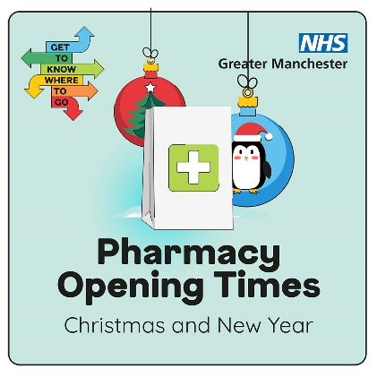 | Some local pharmacies will have different opening hours on Christmas Day, Boxing Day or New Year’s Day.  To find an open pharmacy near you, search: NHS GM pharmacy opening times.  #GTKWTG | Visual contains a cartoon of a white, paper pharmacy bag sitting on some snow. A stack of arrows pointing in different directions contains the words get to know where to go.  Text reads: Looking for a pharmacy. Get to know where to go.  Logo: NHS Greater Manchester
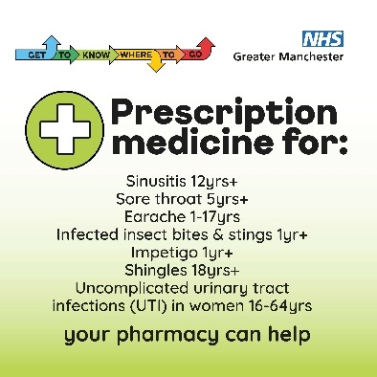 | Your local pharmacy can provide advice and support for a range of minor illness – plus prescription medicines for some common conditions. All without a GP appointment!  Search ‘Greater Manchester Pharmacy First’ to find out more.  #GTKWTG | Visual shows image of a white cross in a green circle. Text reads, Prescription medicine for: Sinusitis 12yrs+, Sore throat 5yrs+, Earache 1-17yrs, Infected insect bites and stings 1yr+, Impetigo 1yr+, Shingles 18yrs+, Uncomplicated urinary tract infections (UTI) in women 16-64 yrs. Your pharmacy can help.  A row of arrows pointing in different directions contains the words get to know where to go.  Logo: NHS Greater Manchester
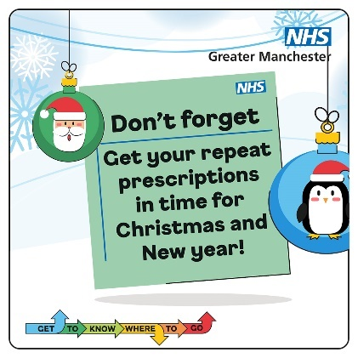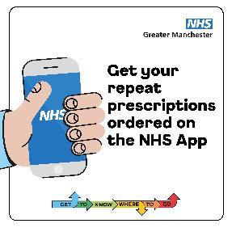 | Christmas is coming!  Don’t forget to order your repeat prescription.  It usually takes 5–7 working days for your medicines to be ready to collect – but remember to order early and allow more time ahead of bank holidays.  Ordering online using the NHS App is the safest and easiest way to order your regular medicines.  #GTKWTG | Visual contains christmas baubles and a green prescription note reading don’t forget to get your prescriptions in time for Christmas and new year. A stack of arrows pointing in different directions contains the words get to know where to go. Logo: NHS Greater Manchester  Visual shows a hand reaching in holding a mobile phone that has the NHS logo on the screen. Text reads: Get your repeat prescriptions ordered on the NHS App. A row of arrows pointing in different directions contains the words get to know where to go. Logo: NHS Greater Manchester
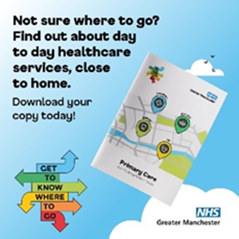 | Our primary care booklet can help you get to know where to go.  It gives an overview of primary care services, what illnesses or health problems they can help with and how to access them.  This makes it easier to choose the right service for you.  To download it, search ‘NHS GM primary care booklet’.  #GTKWTG | Visual contains a picture of the primary care booklet in a cloudy sky. A stack of arrows pointing in different directions contains the words get to know where to go.  Text reads: Not sure where to go? Find out about day to day healthcare services, close to home. Download your copy today!  Logo: NHS Greater Manchester
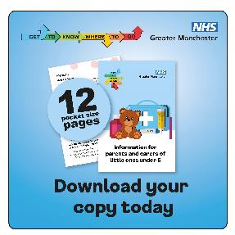 | If you have a little one under 5, take a look at our Get To Know Where To Go leaflet.  It’s packed with tips to handle common illnesses like fever, croup, and earache. Perfect to keep handy for those ‘just in case’ moments.  Search ‘Get To Know Where To Go’  #GTKWTG | Visual contains an image of a leaflet called 'Information for parents and carers of little ones under 5'. The cover shows a teddy bear and a first aid kit. Text reads: 12 pocket size pages. Download your copy today.  A row of arrows pointing in different directions contains the word get to know where to go.  Logo: NHS Greater Manchester
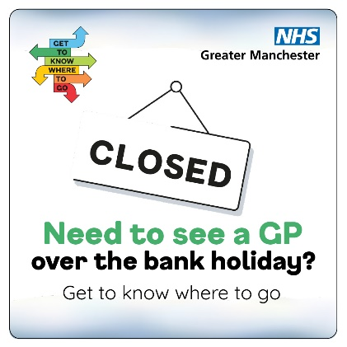 | Need help when your GP practice is closed?  Call your practice and listen to the recorded message. Or call NHS 111 and ask about the GP out of hours service.  If you have a hearing problem, use text relay. Call 18001 111 using the Relay UK app or a text phone.  #GTKWTG #NHS111 | Visual contains a closed sign. A stack of arrows pointing in different directions contains the words get to know where to go.  Text reads: Need to see a GP over the bank holiday? Get to know where to go  Logo: NHS Greater Manchester.
 | Need to see a dentist urgently?  Call the Greater Manchester Urgent Dental Care Service on 0333 332 3800.  Following an assessment, you will be offered a same-day or next-day appointment, given advice, or directed to other services.  #GTKWTG | Visual contains image of a tooth. A stack of arrows pointing in different directions contains the words get to know where to go.  Text reads urgent dental care service. If you don’t have a dentist or your dentist is closed, call 0333 3323800.  Logo: NHS Greater Manchester
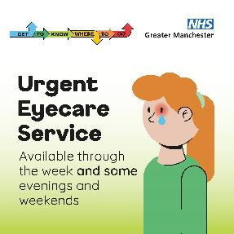 | The urgent eyecare service provides assessment and treatment for eye problems that come on suddenly such as:  - Changes in vision  - A red or painful eye  - Something in your eye that won’t come out  - Flashes or things floating across your eye  To book an assessment search: ‘primary eyecare NHS GM’.  #GTKWTG | Visual contains image of a person with one red eye and a single tear. Text reads urgent eyecare service. Available through the week and some evenings and weekends.  A row of arrows pointing in different directions contains the word get to know where to go.  Logo: NHS Greater Manchester
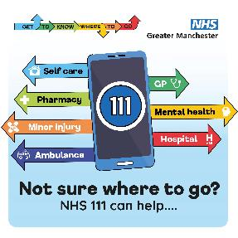 | If you’re not sure what to do or where to go, go to NHS 111 online: www.111.nhs.uk  It’s available 24/7, 365 days a year.  If you need help for a little on under 5, call 111.  For help in BSL, search NHS 111 BSL.  If you have a hearing problem, use text relay. Call 18001 111 using the Relay UK app or a text phone.  #GTKWTG #NHS111 | Visual contains image of a smartphone with 111 displayed on it. Arrows are coming out of it in different colours, indicating different health services. Text reads, Self-care, Pharmacy, Minor injury, Ambulance, GP, Mental health, Hospital. Not sure where to go? NHS 111 can help…  A row of arrows pointing in different directions contains the word get to know where to go.  Logo: NHS Greater Manchester
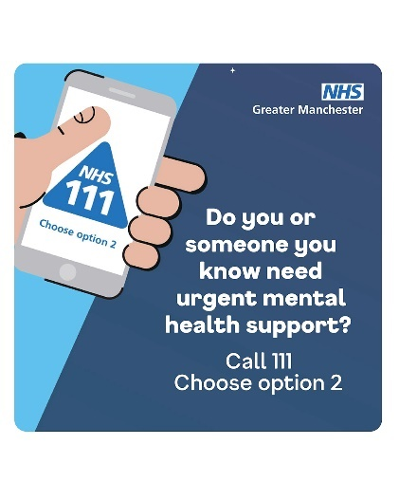 | If you, or someone you know needs urgent mental health support, call NHS 111 and select the mental health option.  Available 24/7, you’ll speak to a mental health professional who can help you find the right support.  #NHS111 #GTKWTG | Visual is split in half. Half of the background is showing a daytime, blue and cloudy sky, the other half is a nighttime starry sky. There is a hand reaching in holding a mobile phone that has the NHS 111 logo on the screen. Text reads: Do you or somoeone you know need urgent mental health support? Call 111. Choose option 2.  Logo: NHS Greater Manchester
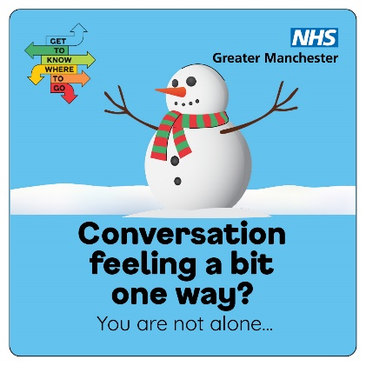 | Christmas can be magical, fun and full of joy – just not for everyone, all of the time…  If you’re just not feeling it this year – you’re not alone!  Learn how to combat loneliness and see how SilverCloud digital mental health programmes can help. https://GM.silvercloudhealth.com/signup  #GTKWTG | Visual contains a cartoon snowman. A row of arrows pointing in different directions contains the word get to know where to go.  Text reads: Conversation feeling a bit one way? You are not alone  Logo: NHS Greater Manchester.
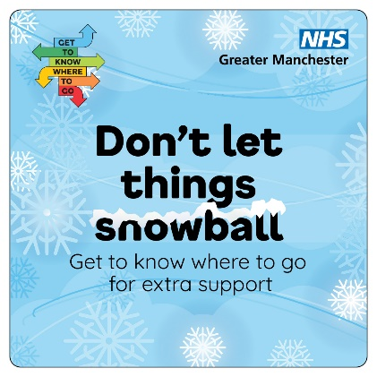 | If you’re struggling and you need a little extra help –just ask!  You can find free, safe and anonymous mental health support on Kooth (ages 10-25) and Qwell (ages 26+)  Search ‘Kooth’ or ‘Qwell | Visual contains lots of snowflakes and a blue snowy sky. A stack of arrows pointing in different directions contains the words get to know where to go.  Text with snow resting on the word snowball reads: Don’t let things snowball know where to go for extra suport.  Logo: NHS Greater Manchester.
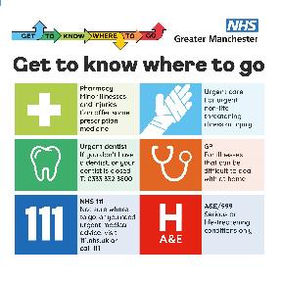 | Here’s a quick guide to help you get to know where to go.  Whether it’s a sore throat or something more serious, finding the right NHS service for your needs can help you get the treatment you need sooner.  Save the post for future reference and share with friends and family.  To find out more search ‘Get To Know Where To Go’  #GTKWTG | In the top left corner is the campaign logo. In the top right corner is the NHS GM logo. In the top left corner is a row of arrows pointing in different directions contains the words get to know where to go.  Informational NHS Greater Manchester poster titled 'Get to know where to go'. It features six coloured sections with icons and guidance: 1) Pharmacy – minor illnesses and injuries; 2) Urgent care – non-life-threatening issues; 3) Urgent dentist – contact 0333 332 3800 if no dentist; 4) GP – for illnesses hard to manage at home; 5) NHS 111 – for urgent advice or if unsure; 6) A&E/999 – for serious or life-threatening conditions only.
Please contact the NHS GM campaigns team if you have any problems downloading from the links provided – gmhscp.gm-campaigns@nhs.net.

