Introduction:
NHS Greater Manchester has begun the next stage of its ‘Keep Protected’ vaccination campaign. This time the focus is on childhood vaccinations, making sure parents and carers of 0-5-year-olds and school-aged children understand the importance of childhood vaccines, what vaccines their children are eligible for and how they get them.
Infectious diseases can be very serious for babies and young children. Illnesses like measles, meningitis and pneumonia can cause serious, life-threatening complications and even be deadly. That’s why babies, young children and teens are offered free and safe NHS vaccinations.

How you can get involved:
This toolkit contains social media copy, social media graphics and newsletter copy aimed at parents and carers of 0-5-year-olds. The vaccines they are eligible for are:
- 6-in-1 vaccine – 4 doses
- Rotavirus vaccine – 2 doses
- MenB vaccine – 3 doses
- Pneumococcal vaccine – 2 doses
- MMRV – 2 doses
- Flu vaccine – every year from 2 or 3-years-old until the end of Year 11 of secondary school
- Pre-school booster (dTAP/IPV) vaccine
You can support the campaign by sharing messages on your own social media channels and newsletters where possible.
Please do also share this toolkit with your partner organisations and stakeholder lists.
To visit the webpage for this campaign, search: NHS GM child vax.

Support the campaign on social media:
The quickest and easiest way to support the campaign is to look out for the campaign assets on our social media channels and share to your followers. If you don’t already follow us, you'll find us here:
- Facebook @NHSGreaterManchester
- Instagram @nhs_gm

Newsletter copy:
Is your baby or little one up-to-date with their vaccines?
Vaccines are an important way of keeping your child protected against lots of different illnesses and diseases that can cause them to be very ill, leave them with long-term disabilities and even kill.
NHS childhood vaccines are safe and free, they give your child’s immune system the extra help it needs to protect against illnesses like whooping cough, meningitis and measles.
Most babies will be offered their first vaccine at 8 weeks old. Staying up to date with your child’s vaccinations throughout their childhood will give them with the best protection but it’s never too late to catch up. To find out what vaccines are offered to newborns, babies and little ones, visit the NHS Greater Manchester website, or search: NHS GM child vax.
It’s natural to have questions about your child’s health — and with so much information out there, it can be hard to know what to believe. The NHS GM website has a helpful myth-busting section to help you separate fact from fiction. Find answers to questions such as what vaccines your children should have, whether they are safe, and if they can overload your child’s immune system. Keep them protected, search: NHS GM child vax.

Social media and toolkit assets:
To download all the available images, please visit the Campaign Resource Centre on the NHS GM website. Please do not copy and paste the images in the table below as they are lower quality.
You may wish to include the link to the childhood immunisations Keep Protected webpage
Asset | Facebook copy | Instagram copy | X copy | Alt text
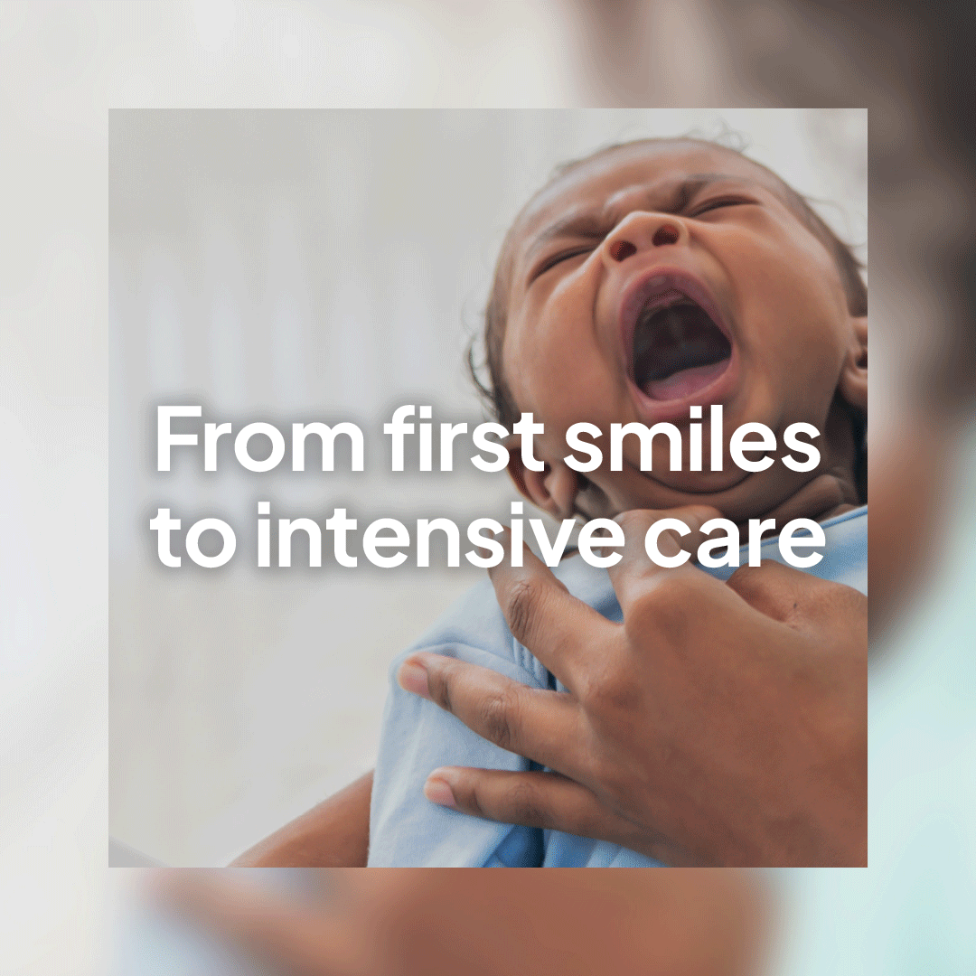  Newborn | Your newborn will be offered their first vaccine from 8-weeks old.  Vaccines help protect them from serious illnesses like whooping cough, meningitis, and measles.  They are safe, free, and gives their immune system the extra help it needs.  Keep them protected. To find out more:  - Search: ‘NHS GM child vax’.  - Speak to your GP practice or health visitor.  #KeepProtected #GreaterManchester #ChildVaccinations #NewbornVaccines | First vaccines for your newborn usually start at 8 weeks.  Vaccines give their immune system extra help to stay safe from serious illnesses like whooping cough, meningitis and measles.  They’re safe, free, and important for your baby’s health.  Want to learn more?  Search: NHS GM child vax, or speak to your GP practice or health visitor.  #KeepProtected #GreaterManchester #ChildVaccinations #NewbornVaccines | Your newborn will be offered their first vaccine from 8 weeks.  Vaccines protect them from serious illnesses. They're safe, free and give their immune system the extra help it needs!  For more info visit gmintegratedcare.org.uk/keep-well/0-to-5-years-immunisations/  #KeepProtected | 4-frame Gif:  First frame shows a distressed newborn crying. Text over the image says ‘From first smiles to intensive care’  Second frame, text on a blue background reads ‘Illnesses like whooping cough, tetanus and meningitis can cause breathing problems, severe dehydration, and brain damage in newborns.’  Third frame, text on a pink background reads ‘Vaccinations from 8 weeks keep them safe from serious illness and even death.’  Fourth frame has the ‘Keep Protected’ campaign logo. With text underneath which reads ‘Speak to your GP practice or health visitor to book your newborn’s vaccinations.’ The NHS GM logo is in the top right corner.
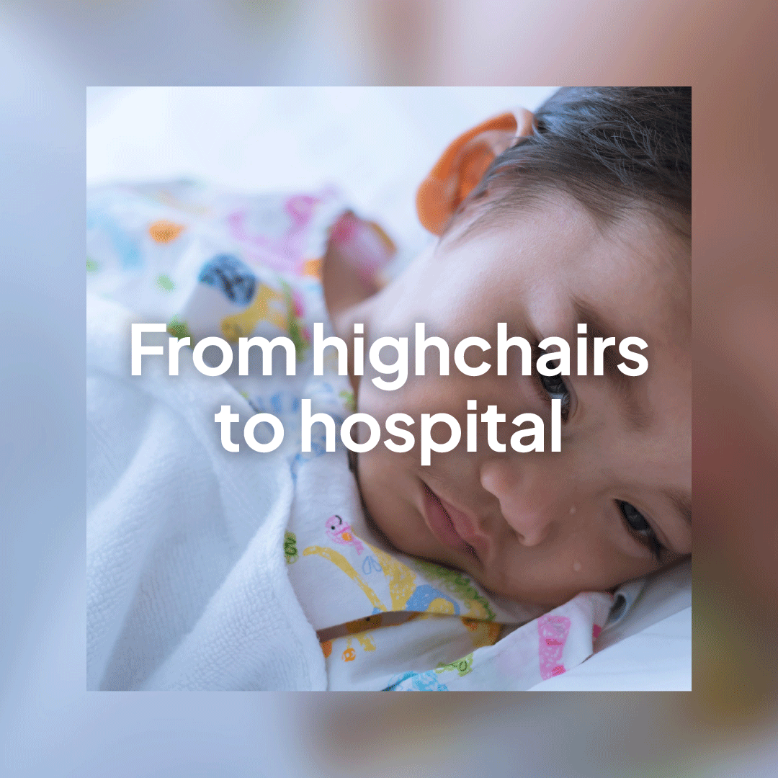  Baby | Vaccines help protect your baby from serious illnesses like measles, sepsis and meningitis.  Staying up to date with their vaccinations is the best way to keep them protected, but it’s never too late to catch up.  To find out more:  - Search: ‘NHS GM child vax’.  - Speak to your GP practice or health visitor.  #KeepProtected #GreaterManchester #ChildVaccinations #BabyVaccines | Vaccines help protect your baby from serious illnesses like measles, sepsis and meningitis.  Staying up to date with their vaccinations is the best way to keep them protect but remember – it’s never too late to catch up!  Want to learn more?  Search: NHS GM child vax, or speak to your GP practice or health visitor.  #KeepProtected #GreaterManchester #ChildVaccinations #NewbornVaccines | Vaccines help protect your baby from serious illnesses like measles, sepsis and meningitis.  Staying up to date is the best way to keep them protected but its never to too late to catch up.  For more info visit gmintegratedcare.org.uk/keep-well/0-to-5-years-immunisations/  #KeepProtected | 4-frame Gif:  First frame shows a baby looking upset and in a hospital bed. Text over the image reads ‘From highchairs to hospital’.  Frame two is text on a blue background which reads ‘Measles, meningitis and pneumonia can cause seizures, hearing loss and brain injury in babies.’  Frame three is text on a pink background which reads ‘You can help keep your baby safe from serious illness and even death by making sure they are vaccinated.’  Fourth frame has the ‘Keep Protected’ campaign logo. With text underneath which reads ‘Speak to your GP practice or health visitor to book your baby’s vaccinations.’ The NHS GM logo is in the top right corner.
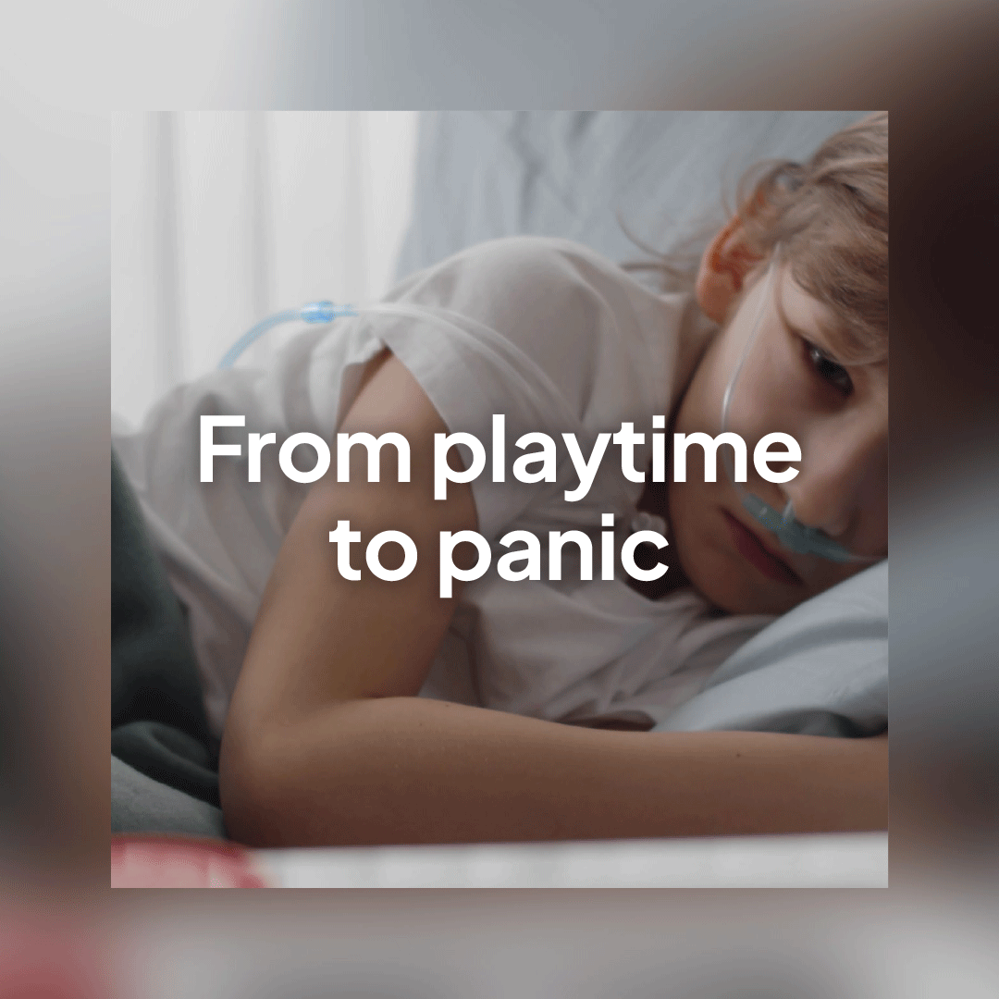  Little one | Vaccines help keep your little one protected from serious illnesses.  Some are given more than once to make sure your child is fully protected.  Speak to your GP practice to book your child’s vaccinations, or for more information search: ‘NHS GM child vax’.  #KeepProtected #GreaterManchester #ChildVaccinations #ToddlerVaccines | Vaccines are the best way to keep your little one safe from serious illnesses like measles and whooping cough.  Some vaccines are given more than once to make sure your child is fully protected – it gives their immune system extra help to fight off the illnesses.  Not sure what vaccines your child needs and when? Speak to your GP practice or search NHS GM child vax.  #KeepProtected #GreaterManchester #ChildVaccinations #ToddlerVaccines | Vaccines keep your little one safe from serious illnesses.  Some are given more than once to make sure they’re fully protected.  Not sure what vaccines your child needs?  Visit gmintegratedcare.org.uk/keep-well/0-to-5-years-immunisations/  for more info.  #KeepProtected | 4-frame Gif:  First frame shows a little child in a hospital bed with a tube around their nose. Text over the image reads ‘From playtime to panic.’  Second frame is text on a blue background which reads ‘Polio, diphtheria and tetanus can cause serious long-term complications and even kill.’  Third frame is text on a pink background which reads ‘You can help keep your child safe from serious illness and even death by making sure they are vaccinated.’  Fourth frame has the ‘Keep Protected’ campaign logo. With text underneath which reads ‘Speak to your GP practice to book your child’s vaccinations.’ The NHS GM logo is in the top right corner.

