Introduction:
NHS Greater Manchester has begun the next stage of its ‘Keep Protected’ vaccination campaign. This time the focus is on childhood vaccinations, making sure parents and carers of 0-5-year-olds and school-aged children understand the importance of childhood vaccines, what vaccines their children are eligible for and how they get them.
Infectious diseases can be very serious for babies and young children. Illnesses like measles, meningitis and pneumonia can cause serious, life-threatening complications and even be deadly. That’s why babies, young children and teens are offered free and safe NHS vaccinations.

How you can get involved:
This toolkit contains social media copy, social media graphics and newsletter copy aimed at parents and carers of school-age children. The vaccines they are eligible for are:
- HPV vaccine – aged 12–13 (year 8)
- Td/IPV (3-in-1 teenager booster) – age 14 (year 9)
- MenACWY – age 14 (year 9)
- Flu vaccine – every year until the end of Year 11 of secondary school)
You can support the campaign by sharing messages on your own social media channels and newsletters where possible.
Please do also share this toolkit with your partner organisations and stakeholder lists.
To visit the webpage for this campaign, search: NHS GM child vax.

Support the campaign on social media:
The quickest and easiest way to support the campaign is to look out for the campaign assets on our social media channels and share to your followers. If you don’t already follow us, you'll find us here:
- Facebook @NHSGreaterManchester
- Instagram @nhs_gm

Newsletter copy:
From cuddles to intensive care, from school runs to sirens and from growing up to gravely ill. Some infectious diseases can be very serious for children and change everything. They can lead to serious long-term complications and even be deadly.

How can I keep my child safe?
Your child’s immune system is amazing. It can fight off coughs, colds, sore throats and earaches. But it needs extra help to protect against illnesses that can be very serious for them.
All NHS childhood vaccinations help strengthen your child’s immune system. They are safe and free.
Your child will be offered vaccines while they are school, these are:
- HPV vaccine – aged 12–13 (year 8) – this protects against human papillomavirus (HPV) which can cause several cancers in later life.
- Td/IPV (3-in-1 teenager booster) – age 14 (year 9) – tops up your child’s protection against tetanus, diphtheria and polio, which can cause heart failure, paralysis and breathing difficulties.
- MenACWY – age 14 (year 9) – helps protect against life-threatening illnesses like meningitis and sepsis.
- Flu vaccine – every year until the end of Year 11 of secondary school) – protects against flu which can serious complications like pneumonia and bronchitis.
To make sure your child gets their vaccine, sign their consent form from school.
It’s natural to have questions about your child’s health — and with so much information out there, it can be hard to know what to believe. Search NHS GM child vax, to find out more about childhood vaccinations.

Social media and toolkit assets:
To download all the available images, please visit the Campaign Resource Centre on the NHS GM website. Please do not copy and paste the images in the table below as they are lower quality.

You may wish to include the link to the childhood immunisations Keep Protected webpage.
See table on next page.
Asset | Facebook copy | Instagram copy | X copy | Alt text
HPV vaccine   | HPV is a very common virus that can affect boys and girls and sometimes cause cancer later in life.  If your child is in Year 8, look out for their vaccine consent form from school and keep them protected.  For more info search ‘NHS GM child vax’.  #KeepProtected #GreaterManchester #ChildVaccinations #SchoolVaccines | HPV is very common and can affect both boys and girls. In some cases, it can cause cancer later in life.  The HPV vaccine helps protect your child. If they’re in Year 8, keep an eye out for their consent form from school.  Find out more by searching ‘NHS GM child vax’  #KeepProtected #GreaterManchester #ChildVaccinations #SchoolVaccines | HPV is very common and can affect both boys and girls. In some cases, it can cause cancer later in life.  If your child is in Year 8, look out for their school vaccine consent form.  For more info, visit gmintegratedcare.org.uk/keep-well/%20school-age-immunisations/  #KeepProtected | 4-frame Gif:  First frame, a young person is sitting on a hospital bed with a gown on. Their back is to us, and they are looking out the window.  Text over image reads ‘From healthy to hospital’.  Second frame is text on a blue background which reads ‘HPV is a common virus that can cause serious cancer later in life.’  Third frame is text on a pink background which reads ‘Both boys and girls can be affected. Protect your child with the HPV vaccine.’  Fourth frame has the ‘Keep Protected’ campaign logo. With text underneath which reads ‘If your child is in Year 8, look out for the HPV vaccine consent form from school.’ The NHS GM logo is in the top right corner.
MenACWY vaccine  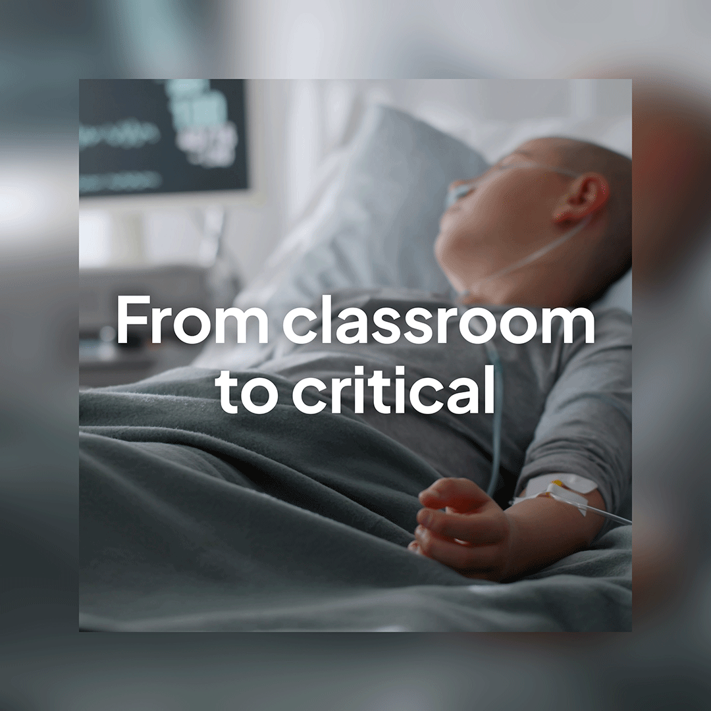 | Meningitis and sepsis can make healthy kids very poorly, very quickly.  If your child is in Year 9, look out for their vaccine consent form from school, and get them vaccinated. It's the best way to keep them protected.  For more info search ‘NHS GM child vax’.  #KeepProtected #GreaterManchester #ChildVaccinations #SchoolVaccines | Meningitis and sepsis can make healthy kids very ill, very quickly.  If your child is in Year 9, look out for their consent form from school and get them vaccinated — it’s the best way to protect them.  For more info, search ‘NHS GM child vax'.  #KeepProtected #GreaterManchester #ChildVaccinations #SchoolVaccines | Meningitis and sepsis can make healthy kids very ill.  Year 9 parents: look out for your child’s school vaccine consent form and get them vaccinated.  For more info, visit gmintegratedcare.org.uk/keep-well/%20school-age-immunisations/  #KeepProtected | 4-frame Gif:  First frame is of a young person ill in a hospital bed with a monitor to the side of them and tubes in their arm. Text over the image reads ‘From classroom to critical’.  Second frame is text on a blue background which reads ‘Meningitis could cause permanent disability or even death. Even healthy kids are at risk’  Third frame is text on a pink background which reads ‘Teens are at risk of being hospitalised with meningitis. Make sure your child is protected.  Fourth frame has the ‘Keep Protected’ campaign logo. With text underneath which reads ‘If your child is in Year 9, look out for the meningitis vaccine consent form from school.’ The NHS GM logo is in the top right corner.
Td/IPV vaccine (3-in-1 teenage booster)  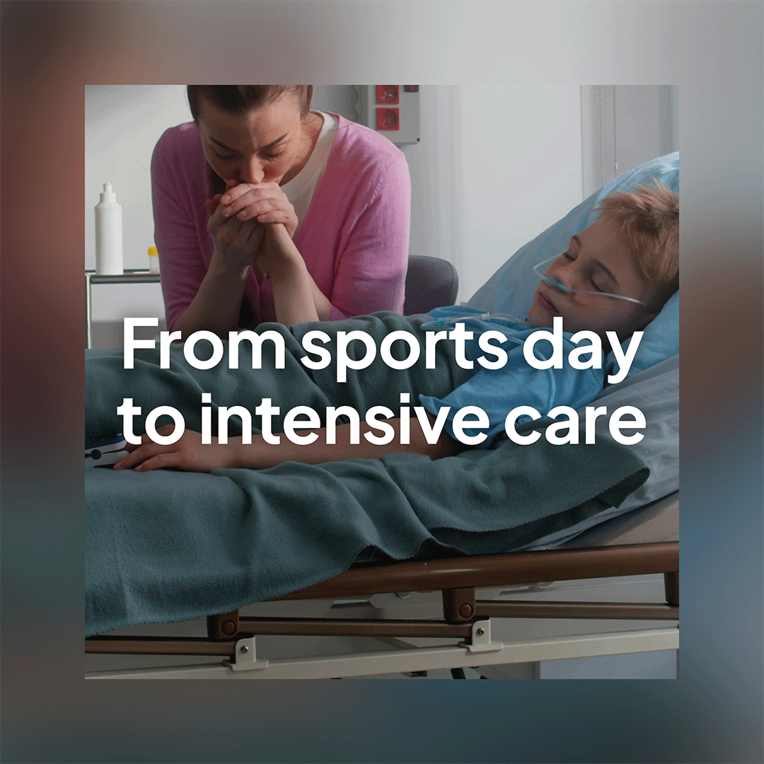 | Polio, diphtheria and tetanus are not a thing of the past. Vaccination is the best way to protect your child. Look out for your child's 3-in-1 booster vaccine consent form.  For more info search ‘NHS GM child vax’.  #KeepProtected #GreaterManchester #ChildVaccinations #SchoolVaccines | Polio, diphtheria and tetanus can still make children seriously ill.  The 3-in-1 booster vaccine helps keep your child protected. Year 9 parents: check for the consent form from school.  Search ‘NHS GM child vax’ for more info.  #KeepProtected #GreaterManchester #ChildVaccinations #SchoolVaccines | Year 9 parents: don’t forget the 3-in-1 booster consent form from school. Protect your child from polio, diphtheria & tetanus.  For more info, visit gmintegratedcare.org.uk/keep-well/%20school-age-immunisations/  #KeepProtected | 4-frame Gif:  First frame is of a young person in a hospital bed. Their eyes are closed and there are tubes in their nose. Someone in a pink top is at their bedside and holding the young person’s hand. Second frame is text on a blue background which reads ‘Polio, diphtheria and tetanus can cause serious long-term complications and even kill.’  Third frame is text on a pink background which reads ‘These diseases are not a thing of the past. Protect your child’s immunity with the 3-in-1 booster.’  Fourth frame has the ‘Keep Protected’ campaign logo. With text underneath which reads ‘If your child is in Year 9, look out for the 3-in-1 vaccine consent form from school.’ The NHS GM logo is in the top right corner.

