Communications toolkit: GM Month of Hope 2026 communications toolkit

Introduction
The Month of Hope runs annually in Greater Manchester from 10 September (World Suicide Prevention Day) until 10 October (World Mental Health Day). It is about raising awareness of suicide by encouraging everyone in Greater Manchester to have open conversations about suicide and play a role in preventing suicide, while inspiring hope across the city region. The Month of Hope is delivered as part of the Shining a Light on Suicide campaign and supports the vision of the GM Suicide Prevention Strategy which launches on World Suicide Prevention Day.
This year’s campaign theme is ‘Changing the Narrative on Suicide’, and we will be raising awareness of the actions we can all take to reduce suicide and instil hope.

How you can get involved
The quickest and easiest way to support the campaign is to look out for the campaign assets on our social media channels and share to your followers. If you don’t already follow us, you'll find us here:
- Facebook @NHSGreaterManchester
- Instagram @nhs_gm @shiningalightonsuicide

Or you can:
- Use the social media assets to schedule posts on your channels
- Promote the campaign using the suggested copy for your communications
- Share this toolkit with partner organisations and stakeholder lists
- Promote the planned activities and events throughout your organisations and charities.

Key messages
During the Month of Hope, we will be utilising the key messages from our Shining a Light on Suicide communications plan.
- Together we can prevent suicide.
- You don’t have to be a health professional to help prevent suicide.
- Silence helps thoughts of suicide grow - a conversation may just stop someone taking their life.
- Whether you’re feeling suicidal, worried someone else is, or have lost someone to suicide, you’re not alone. Whatever you’re going through, find the support you need. Visit www.shiningalightonsuicide.org.uk or call Samaritans on 116 123.
- If you have lost someone to suicide, the Greater Manchester Bereavement Service is there to listen and help you find the right support. It’s a confidential service with dedicated suicide bereavement practitioners, who are there for you no matter how long it’s been. You can access the service by calling 0161 983 0902 or visit
www.greater-manchester-bereavement-service.org.uk.
- Zero Suicide Alliance has created free, 30-minute, online training designed to help people feel more confident talking to people about suicide – it really could save a life.
- Asking about suicide won’t put the idea in someone’s head.

Support

NHS 111
Need urgent help for your mental health?
Call 111 and select the mental health option. Available 24/7, you’ll speak to a mental health professional who can help you find the right support.
Other ways to contact 111:
- Text relay. Call 18001 111 using text relay, 24 hours a day.
- British sign language (BSL) Use signvideo.co.uk/nhs111
- Help in other languages. Call 111 and ask for an interpreter.
If you or someone else have physically harmed themselves, or if their life is at risk, then you should still call 999 or go to A&E.

Greater Manchester Voluntary, Community, Faith and Social Enterprise community mental health crisis drop-in services
These community-based services offer immediate support and de-escalation in a safe environment, a listening ear, crisis management, practical support and a quick referral to a mental health assessment if required. They’re an alternative to A&E and provide easier and more appropriate access for anyone experiencing emotional distress or a mental health crisis. Find a drop-in centre in your locality.

Greater Manchester Bereavement Service
Greater Manchester Bereavement Service can provide support to anyone in Greater Manchester that has been bereaved or affected by a death, no matter how long ago. No one needs to feel alone as they deal with their grief.
Call on 0161 983 0902 for help in finding the right support for you. Lines are open Monday to Friday, 9am to 5pm (except bank holidays.)
Email: gmicb-sal.gm.bs@nhs.net
Or visit the Greater Manchester Bereavement Service website.

Shining a Light on Suicide
The Shining a Light on Suicide website has lots of information to support you if you are having thoughts of suicide, if you are concerned about someone who is suicidal or if you have been bereaved by suicide.
Visit the website here.

Newsletter copy
Greater Manchester’s Month of Hope – Empowering Life-Changing Conversations
This year’s Month of Hope will once again shine a light on suicide prevention by encouraging open, honest conversations and tackling the stigma that can surround suicide and mental health, as we launch the 2026 Greater Manchester Suicide Prevention Strategy.
Running annually across Greater Manchester from 10 September (World Suicide Prevention Day) to 10 October (World Mental Health Day), the campaign brings people together to raise awareness, support one another, and promote meaningful conversations that can make a real difference.
Month of Hope is part of the Shining a Light on Suicide campaign, which aims to bring discussions about suicide out into the open and help create a greater understanding of suicide. The campaign continues to challenge the way suicide is talked about, reinforcing the message that everyone has a role to play in preventing it and supporting those who may be struggling.
One recent initiative encouraged taxi and private hire drivers across Greater Manchester to complete a free online training course, which takes just 10 minutes and helps people recognise the signs that someone may be in distress and know how to respond. With more than 18,500 licensed taxi and private hire drivers in the region having thousands of interactions with passengers every day, even a brief conversation has the potential to make a difference and, in some cases, help save a life.
Judd Skelton, Chair of Greater Manchester Suicide Prevention Programme Board, said:
“We lose more than 200 people a year to suicide across Greater Manchester, but research shows that talking honestly and openly about suicide can help save lives. Research tells us that talking about suicide doesn't put the idea in someone's mind, but can lead to a person feeling supported reducing their risk of taking their life. Just being there to listen and showing you care can help, but people often feel they lack the skills, knowledge, or confidence to talk about suicide. That’s why the Shining a Light on Suicide campaign, alongside Zero Suicide Alliance, is encouraging everyone to set aside just 30 minutes to take its free online training that will help you spot the signs that someone may be thinking of suicide and increase your confidence to talk to them about it.”
You can support the Month of Hope campaign by encouraging conversations, attending one of the events or sharing any Month of Hope social media posts – search using the hashtag #MonthOfHope. You can also access the free online training here www.shiningalightonsuicide.org.uk/learn-to-save-a-life. You can also find the new Suicide Prevention Strategy at www.shiningalightonsuicide.org.uk

Events
To mark the Month of Hope, a number of events are happening across Greater Manchester, to raise awareness and instil hope. These include vigils of remembrance which offer the opportunity to come together as a community and remember those lost to suicide and provide support for the bereaved, along with both in person and virtual events to mark World Suicide Prevention Day 2026.

Greater Manchester Mental Health Horwich Hub Walk of Hope
Date and time: Tuesday 8 September 2026, 12pm – 2pm
Venue: Horwich Town Hall, BL6 7AQ
Join us for a gentle 1.5 to 2-hour circular walk starting and finishing at Horwich Town Hall, taking in Liverpool Castle, Greater House Barn and Horwich Beach along mostly flat country trails.
Please note that some country paths may not be suitable for wheelchairs or prams. Feel free to bring a picnic, drinks and snacks. For more information, contact marc.lowden@gmmh.nhs.uk.

Month of Hope Opening Event
Date and time: Thursday 10 September 2026, 10am – 2pm
Venue: Victoria Square, Bolton, BL1 1RU (Opposite Bolton Town Hall)
Meet local support organisations and access advice, guidance and signposting. The event will feature wellbeing conversations hosted by Manbassadors and the Samaritans. For more information, contact edward.kavanagh@bolton.gov.uk.

Bury Suicide Prevention Day Vigil
Date and time: Thursday 10 September 2026, 6pm – 7:30pm
Venue: Kay Gardens, Bury, BL9 0BL
This vigil will take place in memory of the lives lost to suicide.
The memory walk will start at 6pm from Kay Gardens and finish at the memorial stone in front of Castle Leisure Centre where flowers can be laid. For more information, contact info@thebigfandango.com.

Salford Candlelight Vigil
Date and time: Thursday 10 September 2026, 6pm – 7:30pm
Venue: Salford Museum and Art Gallery, Crescent, Salford, M5 4WU
There will be representatives from local suicide bereavement charities present to offer support.
The event will include contributions from speakers, local poets and music from local artists/choirs. It culminates in a flag parade, candle-lit vigil, and minute silence. It is an evening of reflection, celebration and remembrance.

GM Bereavement Service Pop-Up Event
Date and time: Friday 11 September, 10am – 12pm
Venue: House of Books & Friends, 81 King Street, Manchester, M2 4AH (Ground Floor)
This event coincides with World Suicide Prevention Day, a day dedicated to raising awareness around suicide prevention, mental health support, and breaking the stigma.
Join us to:
- Learn about bereavement and suicide bereavement
- Connect with others
- Hear about our service and speak to a practitioner for help or advice
- Everyone is welcome. Register here.
To find out more about Greater Manchester Bereavement Service visit the website.

Hopeful Horizon Winter, Jaksworld
Date and time: Monday 14 September 2026, 4pm – 8:30pm
Venue: St Clement’s Community Hall, Groves Avenue, Ordsall, M5 3LQ
This year, thanks to funding from The National Lottery Community Fund, an extended programme will be held every Monday from 4pm–8.30pm, running through to 29 March 2027.
As a suicide prevention and postvention charity shaped by lived experience, we know that some of the people who come through our doors have been affected by suicide — through their own experiences, concern for someone they love, or bereavement by suicide. Our lived experience is at the heart of Jak’s World and helps us create spaces where difficult feelings can be spoken about openly, without judgement or the need to explain.
Each Monday will include:
- 4pm – Creative session – different activities and themes throughout the programme
- 6pm – Community meal – a warm meal and an opportunity to sit, eat and connect with others
- 7.30pm – Relaxation session
From January, instead of creative sessions, we will introduce our new Stories of Hope, welcoming guests to share lived experiences, personal journeys and messages of hope.
People can come for one part of the programme or stay for the whole afternoon and evening. No referral is needed, and people do not need to explain why they are coming.

Wellbeing Walk Horwich
Date and time: Monday 14 September 2026, 6pm
Venue: Horwich Leisure Centre, BL6 5YP
Join us for a wellbeing walk in Horwich. The route is approximately three miles and takes around 1.5 to 2 hours, with some slight inclines making it a medium intensity walk. For more information, contact berrytracy04@gmail.com.

New House Wednesday Walkers
Date and time: Wednesday 16 September 2026, 10:30am – 11:30am
Venue: Horwich Leisure Centre, BL6 5YP
This friendly one-hour walk is taken at a slow to moderate pace and welcomes people of all ages. For more information, contact edward.kavanagh@bolton.gov.uk.

Month of Hope Information Event
Date and time: Thursday 17 September 2026, 9am – 12pm
Venue: Bolton Railway Station, Trinity Street, BL2 1BE

6 – A side Football Tournament
Date and time: Friday 18 September 2026, 10am – 12pm
Venue: Burden Park 3G Astro Pitches, BL3 2RS
Hosted by Andrew Farnworth Transforming Lives Group CIC. For more information, contact andyfarny1@gmail.com.

Bolton Walk of Hope
Date and time: Monday 21 September 2026, 12pm
Venue: Victoria Square, Bolton, BL1 1RJ
Join a gentle lunchtime walk, meeting at Victoria Square. The route is approximately 1 to 1.5km, with mainly flat terrain and a slow, relaxed pace suitable for most people. For more information, contact edward.kavanagh@bolton.gov.uk.

Lancashire Wildlife Trust Mindful Walk
Date and time: Thursday 24 September 2026, 11am – 12:30pm
Venue: Rock Hall, Hall Lane, Farnworth, Bolton, BL4 7SF
Join a gentle mindful walk, starting at Rock Hall and finishing at Knob End with free refreshments at the end. For more information, contact swhittle@lancwt.org.uk.

Community Cycle Ride
Date and time: Saturday 26 September 2026, 2pm -5pm
Venue: Bolton Railway Station, BL2 1BE
Join the Community Cycle Ride, meeting outside Bolton Railway Station. The route is approximately 13 miles and follows a round trip to Parr Fold Park in Walkden before returning to Bolton. For more information, contact selcrp@phonecoop.coop.

Manbassadors Walk
Date and time: Monday 28 September 2026, 10:30am
Venue: The Hive, Moss Bank Park, BL1 6NB
Join the Manbassadors Walk, approximately a three-mile walk which follows a mix of road and off-road terrain, with mainly flat sections as well as some inclines and steps.
Walking boots are recommended, and a refreshment stop is included along the route. For more information, contact rowan.ardill@beonehomes.com.

Greater Manchester Farnworth Walk of Hope
Date and time: Tuesday 29 September, 1pm
Venue: Farnworth Library, Farnworth Town Hall, BL4 7PG
Join us for a six-kilometre route that includes Moses Gate Country Park. The walk takes around two hours and follows a mix of road and country trails.
Feel free to bring a picnic, drinks and snacks. For more information, contact marc.lowden@gmmh.nhs.uk.

Moss Bank Park Health Walk
Date and time: Wednesday 30 September 2026, 1pm
Venue: Main car park, Moss Bank Park, BL1 6NB
Join the Moss Bank Park Health Walk, an approximately four-mile route through the park. The walk takes around two hours and is of medium intensity, following unpaved paths.
Suitable footwear is advised, and dogs are not permitted. For more information, contact roger.marks1@btinternet.com.

Community Rail Trail Walk
Date and time: Thursday 1 October 2026, 1pm – 3:30pm
Venue: Bolton Railway Station, BL2 1BE (near Clock Tower)
Attend the community walk starting at Bolton Railway Station and finishing at Hall-I’th’ Wood Station. The distance is four miles and takes approximately 2.5 hours. A free train journey will be provided back to Bolton Railway station. For more information, contact selcrp@phonecoop.coop.

The Well Walk - Farnworth
Date and time: Wednesday 7 October 2026, 12pm – 1pm
Venue: Trafford Street, Farnworth, BL4 7PQ
Join our 30-minute low-intensity walk followed by free tea and coffee after the walk. For more information, contact dilni@farnworthbaptist.org.uk.

Month of Hope Closing Event
Date and time: Friday 9 October 2026
Venue: TBC

Social Media copy
To download all the available images, please visit the Campaign Resource Centre on the NHS GM website. Please do not copy and paste the images in the table below as they are low quality. You may wish to include the link to the relevant web page in the first comment of a Facebook post, as this can improve engagement levels.
Asset | Platform | Copy | ALT Text for Asset
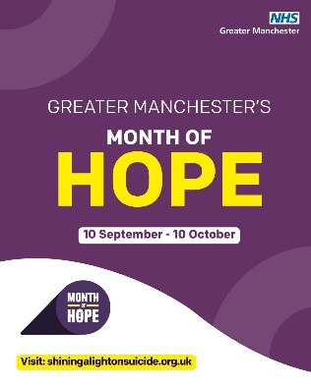  Month of Hope 2026 | Instagram | Greater Manchester’s Month of Hope runs from 10th September-10th October. It’s a time for us to raise awareness of suicide and encourage everyone to have open conversations and play a role in preventing suicide, whilst sharing messages of hope.  Join the conversation and help us change the narrative on suicide.  Search Month of Hope 2026 to find out more.  #MonthOfHope #ShiningALightOnSuicide #GreaterManchesterEvents #Hope #EndTheStigma | Image for Greater Manchester's 'Month of Hope' campaign, running from 10 September to 10 October, organised by NHS Greater Manchester. Features large text for 'HOPE' and includes the website address 'shiningalightonsuicide.org.uk' at the bottom of the image.
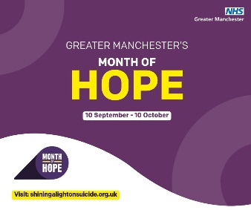  Month of Hope 2026 | Facebook | Greater Manchester’s Month of Hope runs from 10th September – 10th October. It’s a time for us to raise awareness of suicide and encourage everyone to have open conversations and play a role in preventing suicide, whilst sharing messages of hope.  Lots of events will be taking place throughout the month, including vigils of remembrance offering the chance for us to come together and honour those lost to suicide, along with both in person and virtual events to mark #WorldSuicidePreventionDay.  Join the conversation and help us change the narrative on suicide. Search Month of Hope 2026 to find out more.  #MonthOfHope #ShiningALightOnSuicide #GreaterManchesterEvents #Hope #EndTheStigma  Link for comments [add link to webpage] | Image for Greater Manchester's 'Month of Hope' campaign, running from 10 September to 10 October, organised by NHS Greater Manchester. Features large text for 'HOPE' and includes the website address 'shiningalightonsuicide.org.uk' at the bottom of the image.
Month of Hope 2026 reel | Instagram or Facebook | Greater Manchester’s Month of Hope runs from 10th September – 10th October. Join the conversation and help us change the narrative on suicide.  Search Month of Hope 2026 to find out more and for updates on events taking place throughout the month.  #MonthOfHope #ShiningALightOnSuicide #GreaterManchesterEvents #Hope #EndTheStigma | n/a
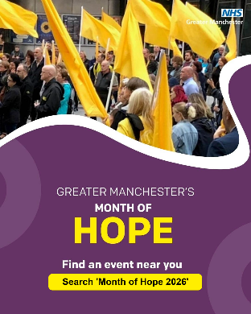  MoH 2026 events | Instagram | From 10th September – 10th October, the Greater Manchester Month of Hope will include lots of events including vigils, memorial walks, virtual events and education sessions to honour and remember those lost to suicide.  Whether you’ve been personally affected or want to learn how to support others, there’s a place for you in this important conversation.  Search Month of Hope 2026 for event details.  #MonthOfHope #ShiningALightOnSuicide #GreaterManchester #Events #Hope #EndTheStigma | Promotional graphic for Greater Manchester’s Month of Hope. Upper section shows a crowd of people holding large yellow flags. NHS Greater Manchester logo is in the top right corner. Lower section has text: 'Greater Manchester’s Month of Hope. Find an event near you. Search ‘Month of Hope 2026’
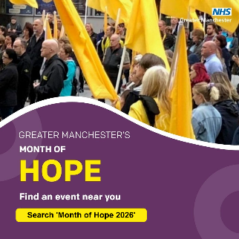  MoH 2026 events | Facebook | From 10th September – 10th October, the Greater Manchester Month of Hope will include lots of events including vigils, memorial walks, virtual events and education sessions to honour and remember those lost to suicide.  Whether you’ve been personally affected or want to learn how to support others, there’s a place for you in this important conversation.  To find an event near you visit the link in the comments below, or search ‘Month of Hope 2026’.  #MonthOfHope #ShiningALightOnSuicide #GreaterManchester #Events #Hope #EndTheStigma  Link for comments [add link to webpage] | Promotional graphic for Greater Manchester’s Month of Hope. Upper section shows a crowd of people holding large yellow flags. NHS Greater Manchester logo is in the top right corner. Lower section has text: 'Greater Manchester’s Month of Hope. Find an event near you. Search ‘Month of Hope 2026’
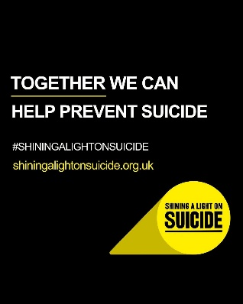  SALOS 1 IG | Instagram | Anyone can experience suicidal thoughts, and it can feel hard to know how to talk to someone about it.  If you’re feeling suicidal, worried someone else is, or have lost someone to suicide, you’re not alone.  You can also call Samaritans free at any time on 116 123.  Search ‘Shining a light on suicide’ or visit their website for support.  #ShiningALightOnSuicide #MonthOfHope #GreaterManchester #Events #Hope #EndTheStigma | Plain image with text reading: ‘TOGETHER WE CAN HELP PREVENT SUICIDE’. Below is the hashtag #SHININGALIGHTONSUICIDE and the website address shiningalightonsuicide.org.uk. At the bottom right is a spotlight graphic with the words ‘SHINING A LIGHT ON SUICIDE’ inside.
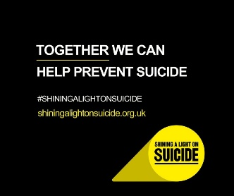  SALOS 1 FB | Facebook | Anyone can experience suicidal thoughts, and it can feel hard to know how to talk to someone about it.  If you’re feeling suicidal, worried someone else is, or have lost someone to suicide, you’re not alone. Visit the Shining a Light on Suicide website for support, we’ll post the link in the comments.  You can also call Samaritans free at any time on 116 123.  #ShiningALightOnSuicide #MonthOfHope #GreaterManchester #Events #Hope #EndTheStigma  Link for comments: shiningalightonsuicide.org.uk | Plain image with text reading: ‘TOGETHER WE CAN HELP PREVENT SUICIDE’. Below is the hashtag #SHININGALIGHTONSUICIDE and the website address shiningalightonsuicide.org.uk. At the bottom right is a spotlight graphic with the words ‘SHINING A LIGHT ON SUICIDE’ inside.
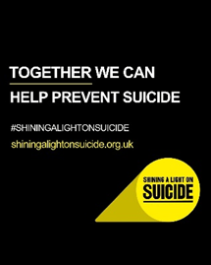  SALOS 1 IG | Instagram | Need urgent help for your mental health?  Call 111 and select the mental health option. Available 24/7, you’ll speak to a mental health professional who can help you find the right support.  If you or someone else have physically harmed themselves, or if their life is at risk, then you should call 999 or go to A&E.  Search ‘Shining a light on suicide’ for links to further support.  #ShiningALightOnSuicide #MonthOfHope #GreaterManchester #Events #Hope #EndTheStigma | Plain image with text reading: ‘TOGETHER WE CAN HELP PREVENT SUICIDE’. Below is the hashtag #SHININGALIGHTONSUICIDE and the website address shiningalightonsuicide.org.uk. At the bottom right is a spotlight graphic with the words ‘SHINING A LIGHT ON SUICIDE’ inside.
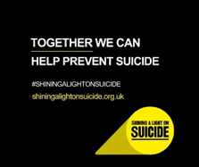  SALOS 1 FB | Facebook | Need urgent help for your mental health?  Call 111 and select the mental health option. Available 24/7, you’ll speak to a mental health professional who can help you find the right support.  If you or someone else have physically harmed themselves, or if their life is at risk, then you should call 999 or go to A&E.  Search ‘Shining a light on suicide’ for links to further support.  #ShiningALightOnSuicide #MonthOfHope #GreaterManchester #Events #Hope #EndTheStigma  Link for comments: shiningalightonsuicide.org.uk | Plain image with text reading: ‘TOGETHER WE CAN HELP PREVENT SUICIDE’. Below is the hashtag #SHININGALIGHTONSUICIDE and the website address shiningalightonsuicide.org.uk. At the bottom right is a spotlight graphic with the words ‘SHINING A LIGHT ON SUICIDE’ inside.
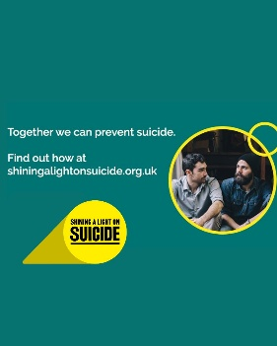  SALOS 2 | Instagram | Suicide affects us all. The Shining a Light on Suicide website has information to help you learn about the warning signs and the things you can do to help someone who may be thinking of suicide. There’s also help and support available if you are feeling suicidal or if you have been bereaved by suicide.  Together we can prevent suicide.  Whatever you’re going though, visit the website to find the support you need – search ‘Shining a light on suicide’.  #ShiningALightOnSuicide #MonthOfHope #GreaterManchester #Hope #EndTheStigma | Suicide prevention awareness graphic. Text reads: 'Together we can prevent suicide. Find out how at shiningalightonsuicide.org.uk'. The 'Shining a Light on Suicide' logo is on the left. On the right, a photo shows two men sitting close together, one with a beard and beanie, the other looking at him supportively.
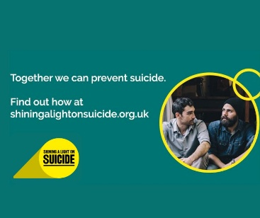  SALOS 2 | Facebook | Suicide affects us all. The Shining a Light on Suicide website has information to help you learn about the warning signs and the things you can do to help someone who may be thinking of suicide. There’s also help and support available if you are feeling suicidal or if you have been bereaved by suicide.  Together we can prevent suicide.  Whatever you’re going though, visit the website to find the support you need. Find a link to the website in the comments.  #ShiningALightOnSuicide #MonthOfHope #GreaterManchester #Hope #EndTheStigma  Link for the comments: www.shiningalightonsuicide.org.uk | Suicide prevention awareness graphic. Text reads: 'Together we can prevent suicide. Find out how at shiningalightonsuicide.org.uk'. The 'Shining a Light on Suicide' logo is on the left. On the right, a photo shows two men sitting close together, one with a beard and beanie, the other looking at him supportively.
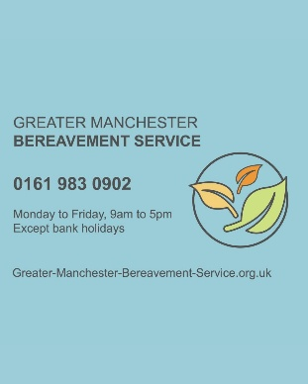  GMBS | Instagram | The Month of Hope is a chance for us to raise awareness of suicide and highlight the support available for anyone affected by it. Any bereavement is hard but losing someone to suicide can bring different challenges.  The Greater Manchester Bereavement Service can help to find support for anyone in Greater Manchester who has been bereaved or affected by a death, no matter how long ago.  You don’t have to deal with your grief alone.  They’re open Monday-Friday 9am-5pm. Call 0161 983 0902 or visit their website by searching Greater Manchester Bereavement Service.  #MonthOfHope #BereavementSupport #ShiningALightOnSuicide #GreaterManchester #Bereavement | A graphic for the Greater Manchester Bereavement Service. Telephone number 0161 983 0902. They are open Monday to Friday, 9am-5pm, except bank holidays. Website address is www.greater-manchester-bereavement-service.org.uk
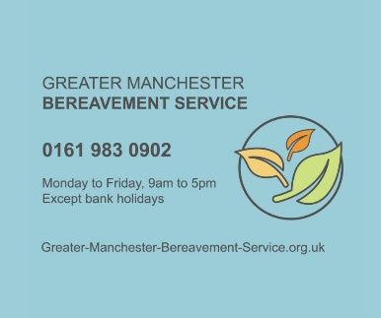  GMBS | Facebook | The Month of Hope is a chance for us to raise awareness of suicide and highlight the support available for anyone affected by it. Any bereavement is hard but losing someone to suicide can bring different challenges.  The Greater Manchester Bereavement Service can help to find support for anyone in Greater Manchester who has been bereaved or affected by a death, no matter how long ago.  You don’t have to deal with your grief alone.  They’re open Monday-Friday 9am-5pm. Call 0161 983 0902.  You can also visit their website for bereavement support in your borough. We’ll post the link in the comments below.  #MonthofHope #BereavementSupport #ShiningALightOnSuicide #GreaterManchester #Bereavement  Link for comments: Home - Greater Manchester Bereavement Service | A graphic for the Greater Manchester Bereavement Service. Telephone number 0161 983 0902. They are open Monday to Friday, 9am-5pm, except bank holidays. Website address is www.greater-manchester-bereavement-service.org.uk
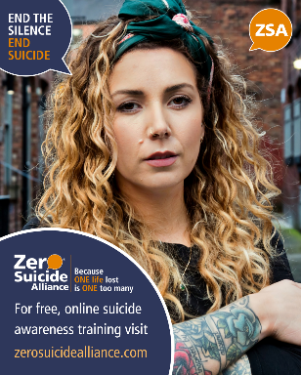  ZSA | Instagram | It can be hard to know how to support someone who you think might be thinking of suicide. Zero Suicide Alliance have created free online training that will give you the skills you need to help someone who is struggling with suicidal thoughts.  Learn to save a life and help change the narrative around suicide.  Search ‘Zero Suicide Alliance’ or visit the Shining a Light on Suicide website for links to the training.  #MonthOfHope #SaveALife #ShiningALightOnSuicide #GreaterManchester #ZeroSuicideAlliance | Head and shoulders image of a woman with long curly hair. Speech bubble in the top left reads 'End the silence, end suicide' and another in the top right says 'ZSA'. Text at the bottom promotes Zero Suicide Alliance with the message 'Because one life lost is one too many' and provides the website zerosuicidealliance.com for free online suicide awareness training.
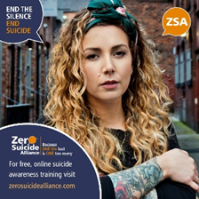  ZSA | Facebook | It can be hard to know how to support someone who you think might be thinking of suicide. Zero Suicide Alliance have created free online training that will give you the skills you need to help someone who is struggling with suicidal thoughts.  Training takes just 30 minutes with additional training available focused on veterans, University students and autistic people.  Search ‘Zero Suicide Alliance’ or visit the link in the comments.  #MonthOfHope #SaveALife #ShiningALightOnSuicide #GreaterManchester #ZeroSuicideAlliance  Link for comments: Learn to Save a Life - Shining a Light on Suicide | Head and shoulders image of a woman with long curly hair. Speech bubble in the top left reads 'End the silence, end suicide' and another in the top right says 'ZSA'. Text at the bottom promotes Zero Suicide Alliance with the message 'Because one life lost is one too many' and provides the website zerosuicidealliance.com for free online suicide awareness training.

World Suicide Prevention Day Assets
Papyrus Prevention of Young Suicide is a UK charity dedicated to the prevention of suicide in young people. They have created a supporter pack to help you speak openly, safely and compassionately about suicide. Access the pack here [add link]

